Introduction Oracle SQL and PL/SQL
Login to SCOTT schema and write queries for the following:

Module 1/Day 1
SELECT Statement:
- List tables in your schema and check for existence of DEPT, EMP and SALGERADE tables
Select * from all_tables;
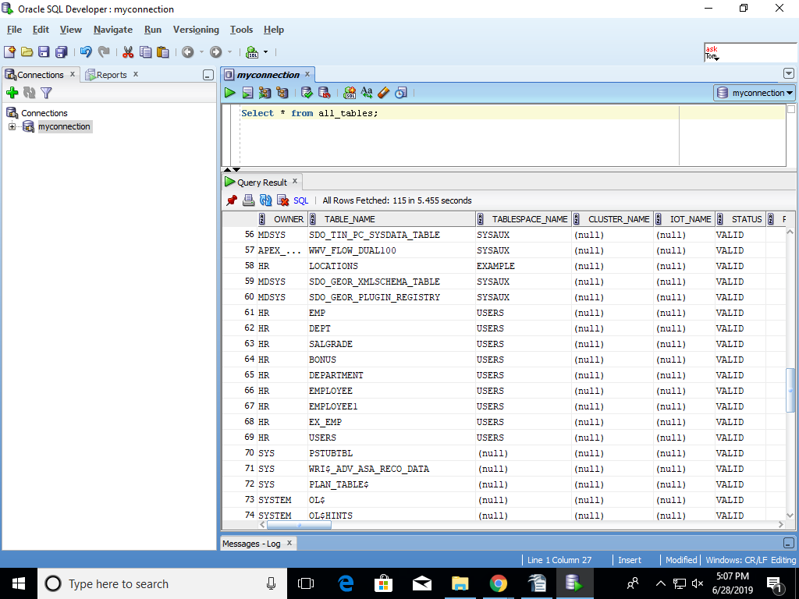
- If these tables do NOT exists – execute the script in the embedded DemoBld.SQL file to create and populate the tables .
- List all columns and all rows from DEPT
select * from DEPT;
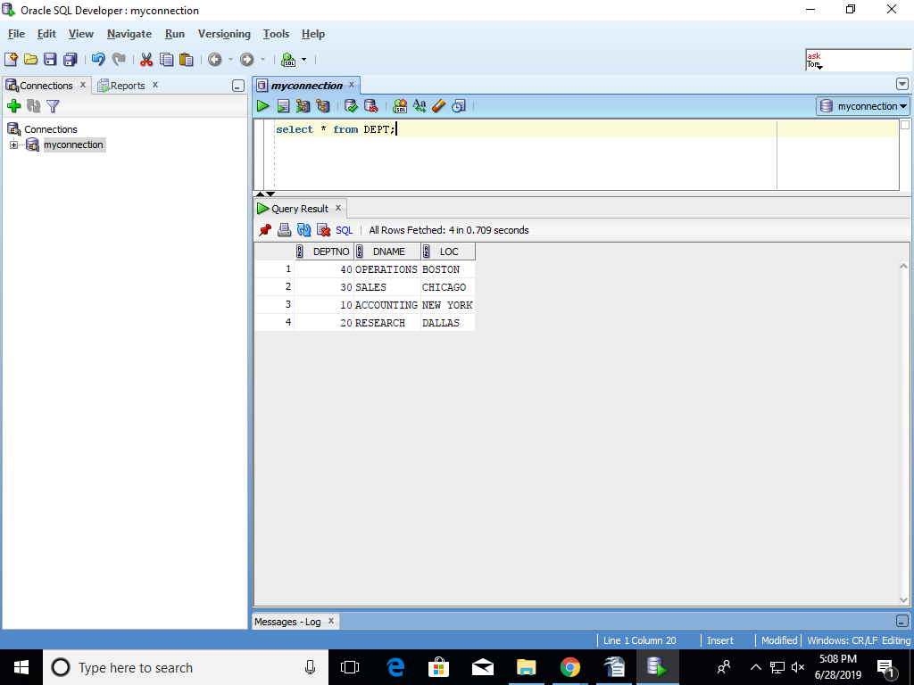
- List all columns and all rows from EMP
select * from EMP;
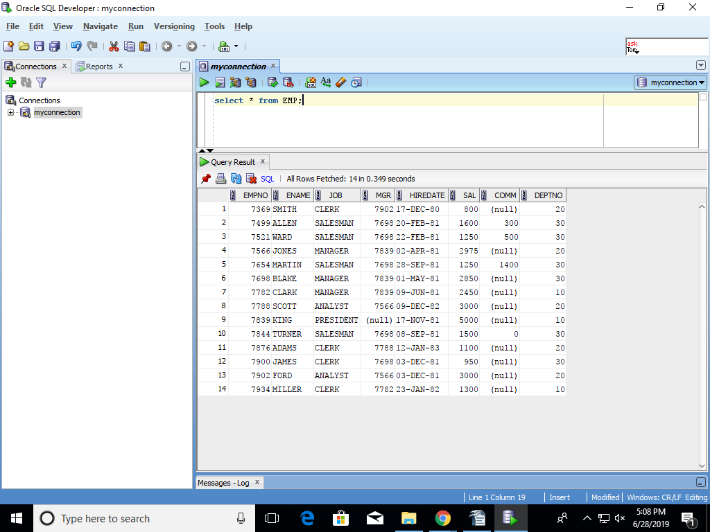
- List all columns and all rows from SALGRADE
select * from SALGRADE;
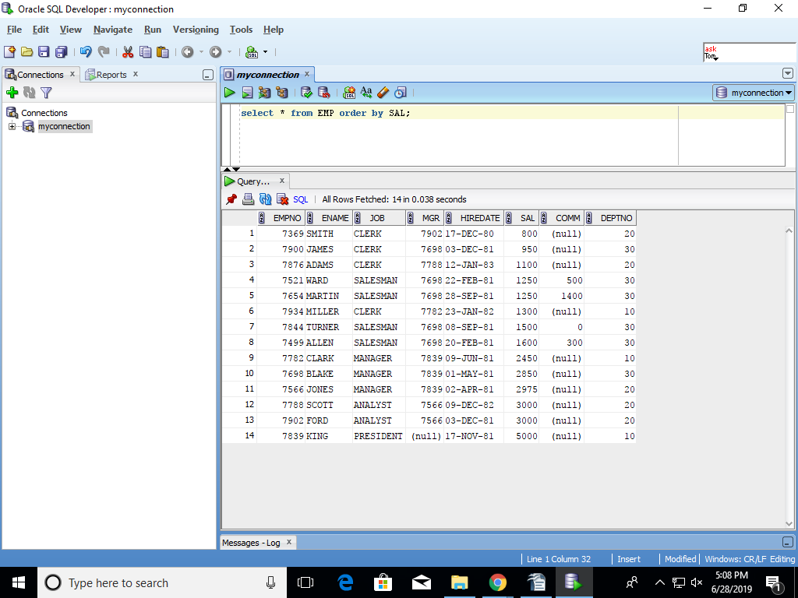

- List employee number, name and salary from employee table
select EMPNO,ENAME,SAL from EMP;

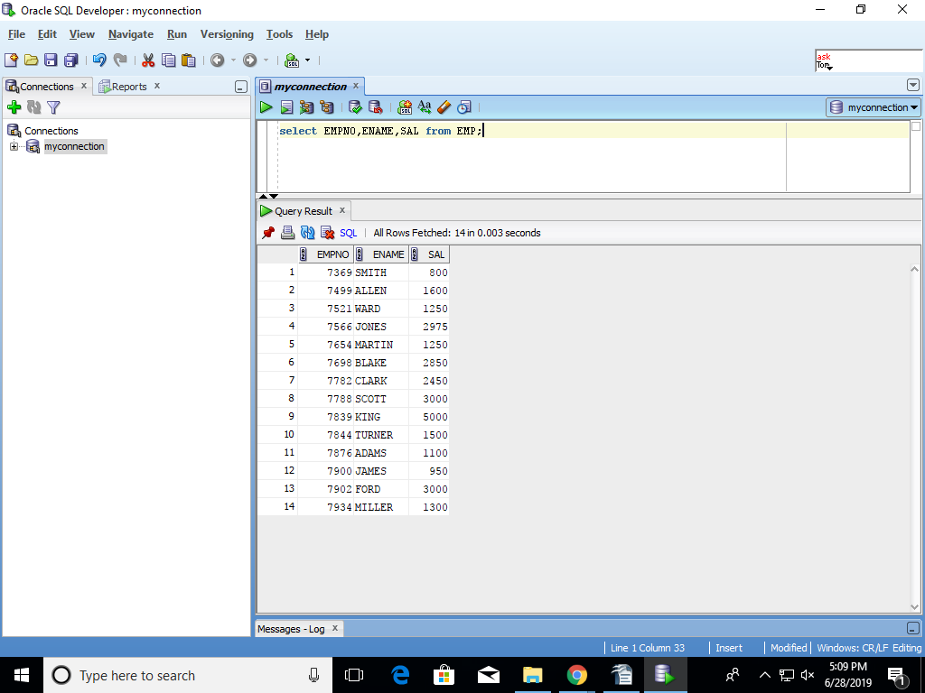
- List employee number, name and salary from employee table where salary is > 3000
select EMPNO,ENAME,SAL from EMP where SAL>3000;
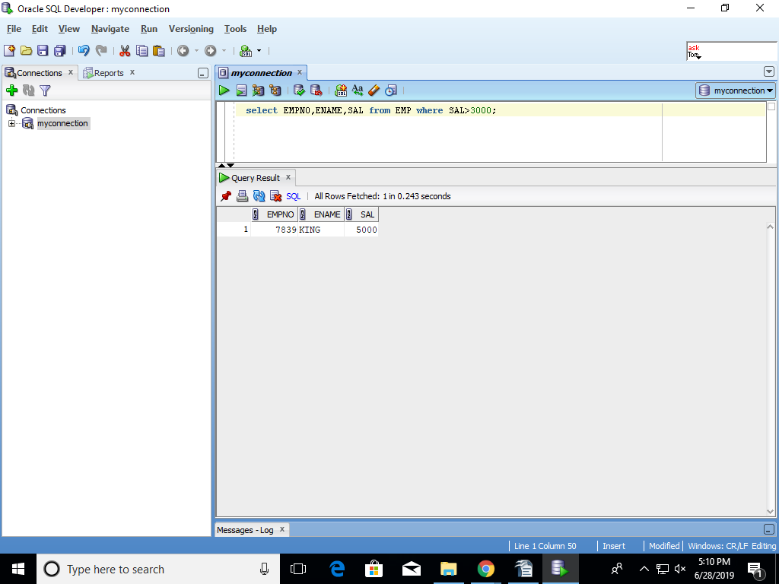

- List employees joined after year 1981
select * from EMP where HIREDATE>('01-JAN-1981');
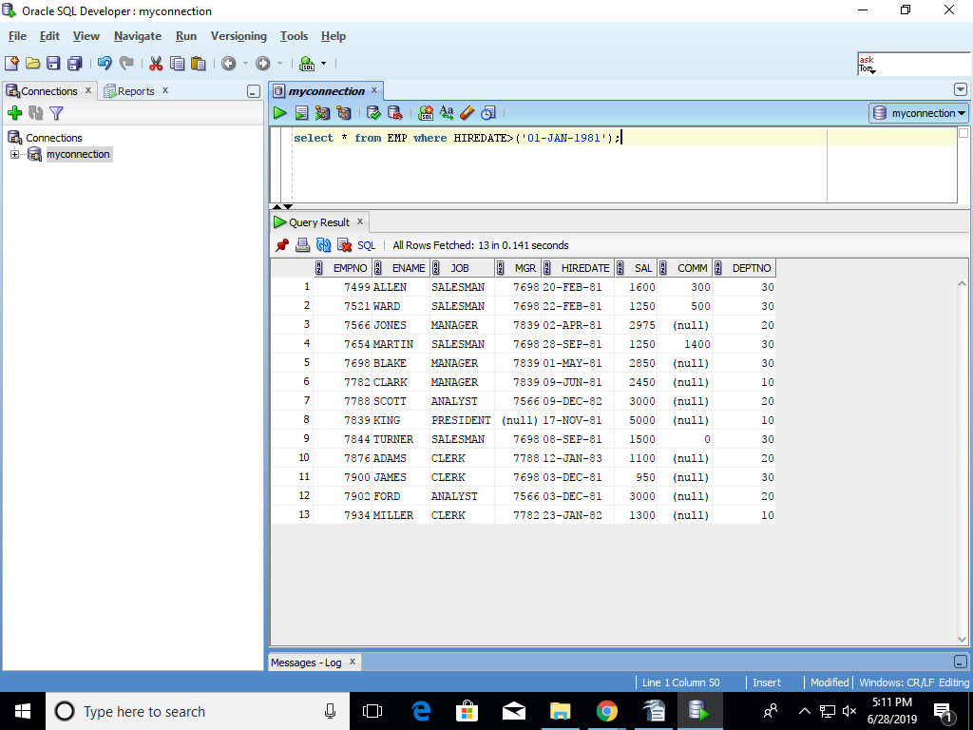
- List all clerks (JOB = ‘CLERK’)
SELECT * FROM EMP WHERE JOB='CLERK';
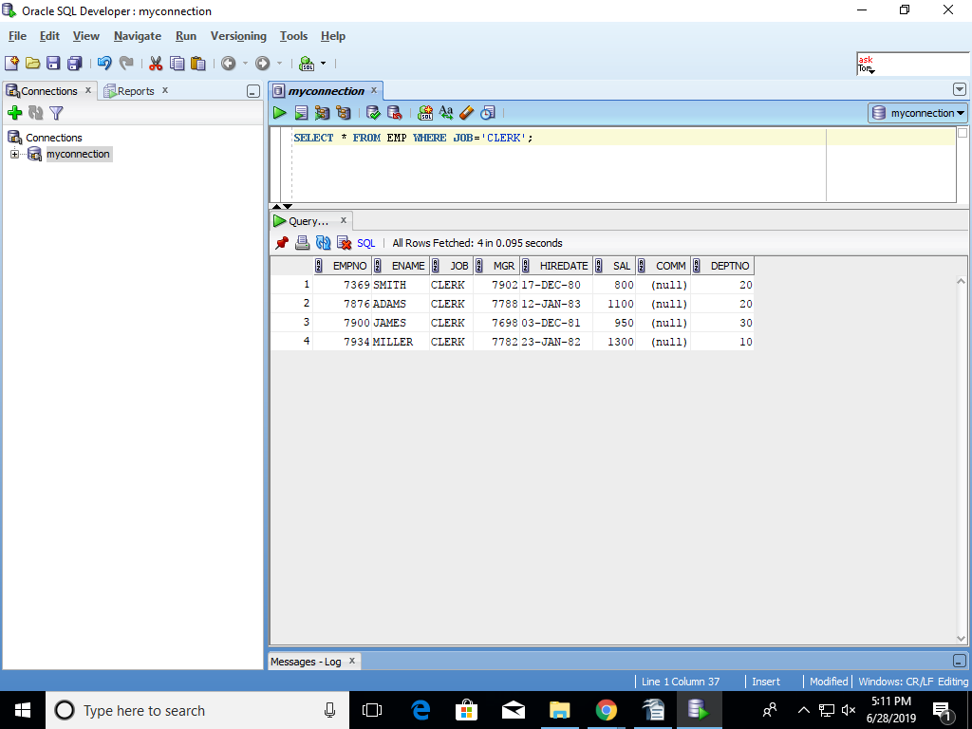

- List employees in the ascending order of salary
select * from EMP order by SAL;
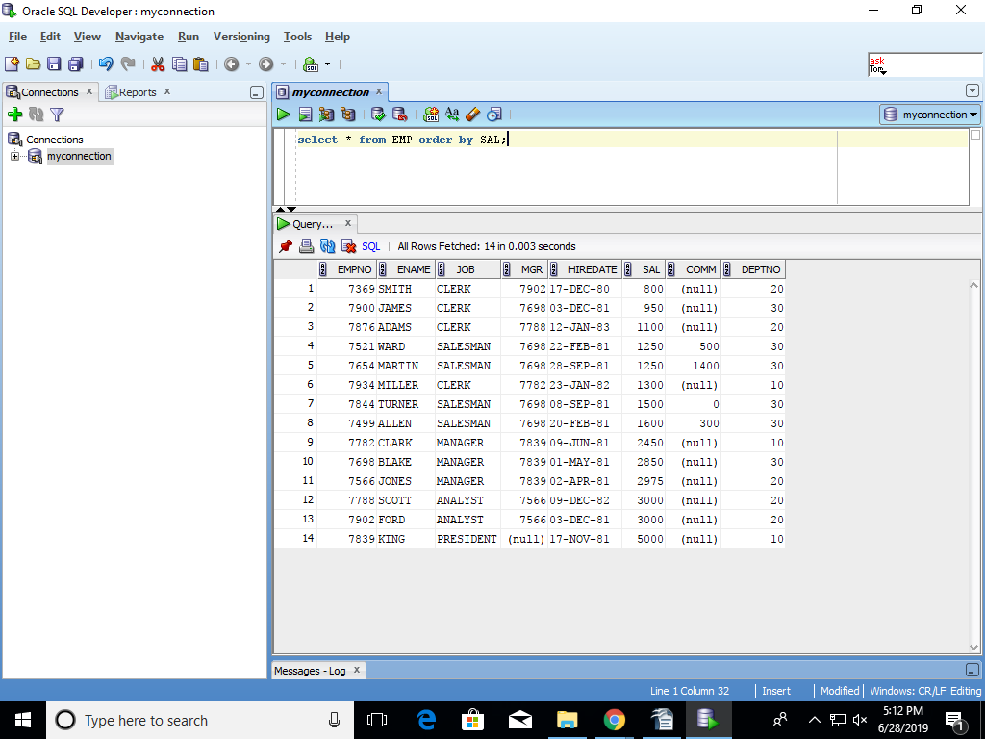

- list employees in ascending order of job within descending order of deptno
select * from EMP order by DEPTNO DESC,job ASC;
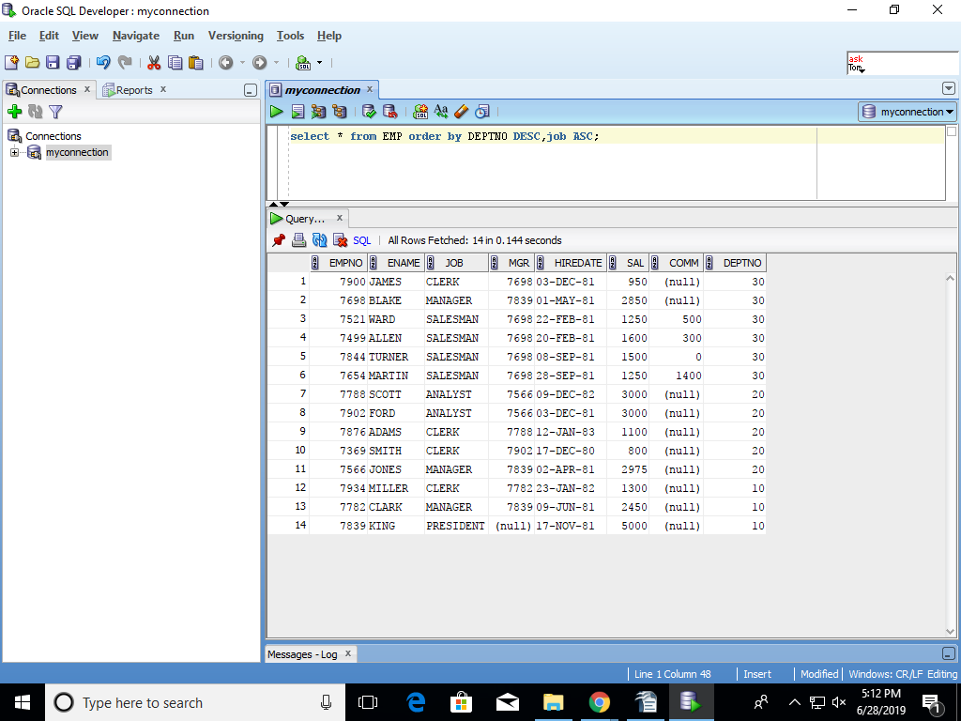

- List distinct departments from employee table
select DISTINCT DEPTNO from EMP ;
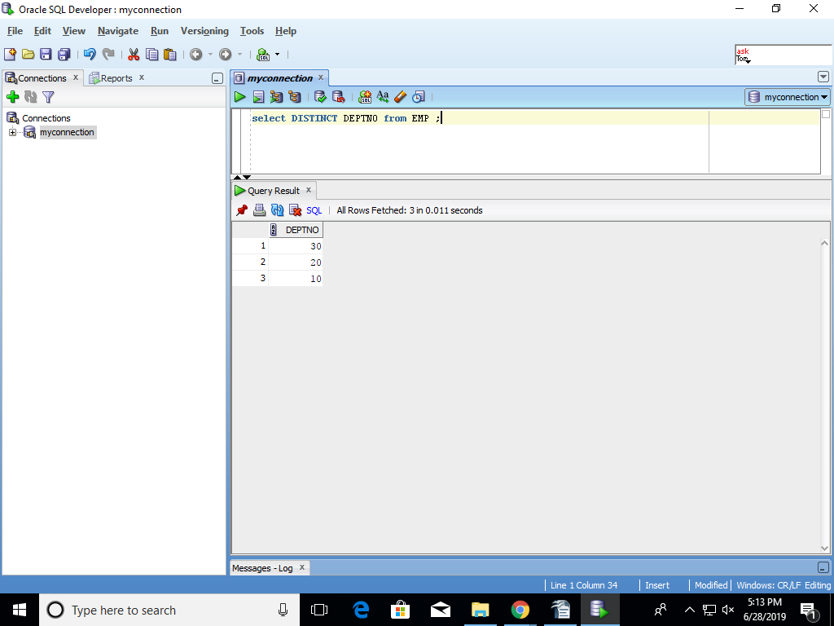

- List distinct jobs in each department from employee table
select DISTINCT E.JOB from EMP E,DEPT D WHERE E.DEPTNO=D.DEPTNO ;
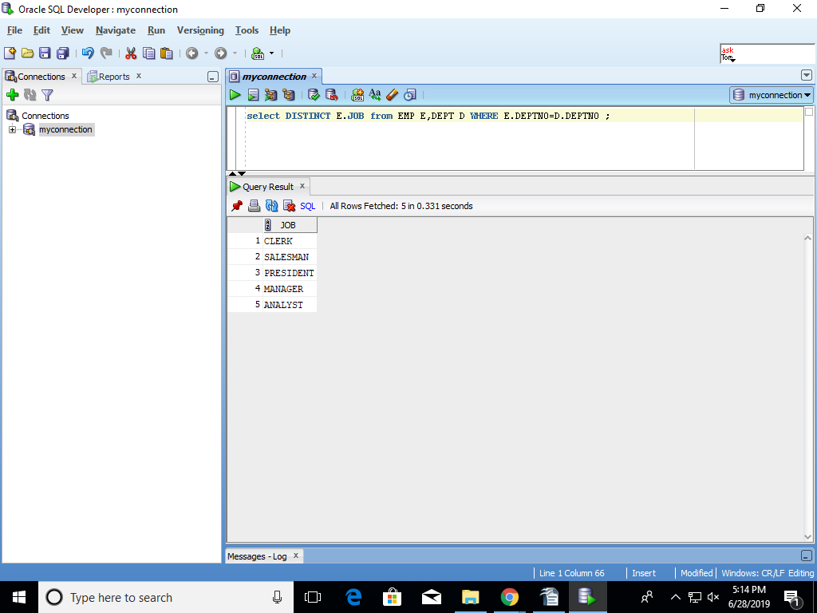

- list name, salary and annual salary in the descending order of annual salary – annual salary is a computed column – SAL * 12
select ENAME,SAL,SAL*12 "ANUAL SALARY"from EMP ORDER BY SAL*12 desc;
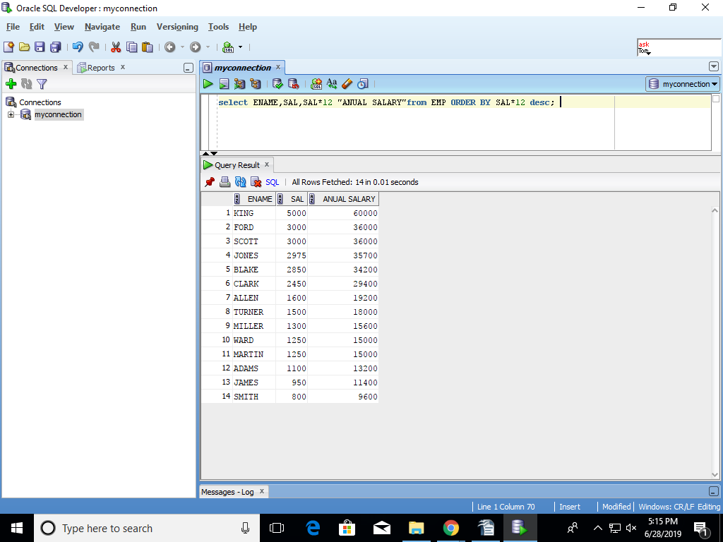

- List employees whose salary is not in the range of 2000 and 3000
select * from EMP where SAL NOT BETWEEN 2000 AND 3000;
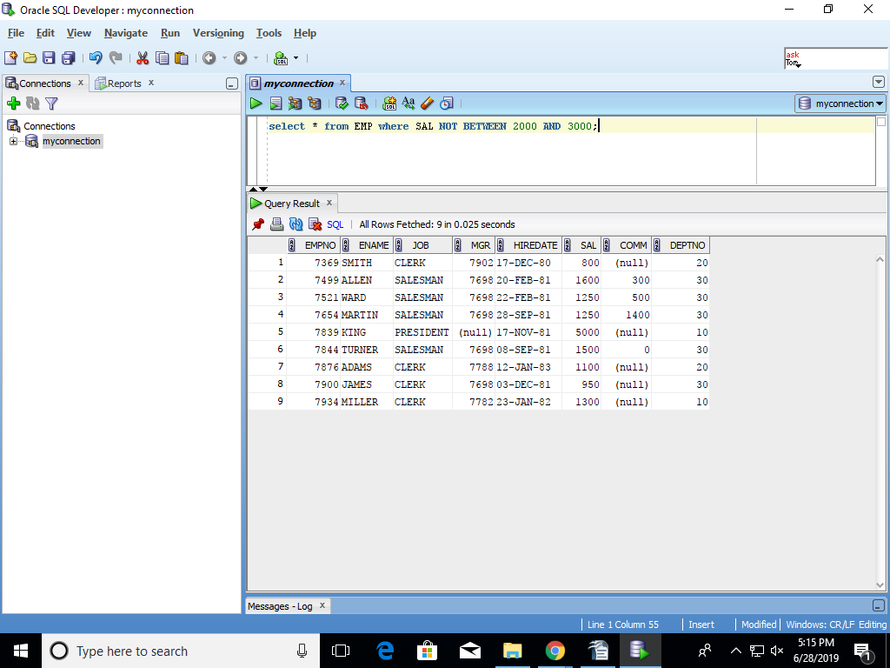

- List name and the deptno for all employees who are NOT members of departments 10 and 20
SELECT ENAME,DEPTNO from EMP where DEPTNO!=10 and DEPTNO!=20;
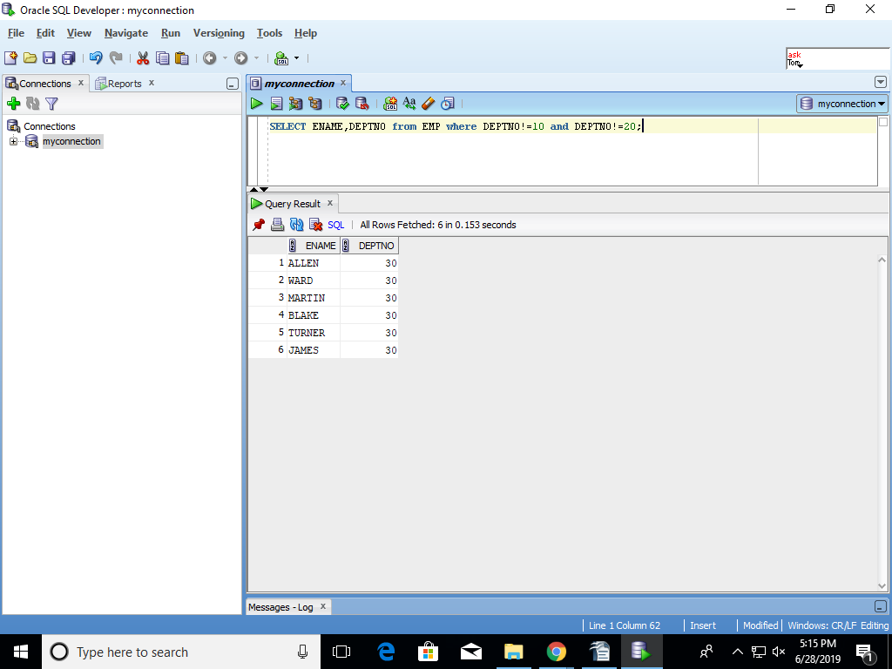
- List employees for whom COMM is not applicable
select * from EMP where COMM IS NULL;
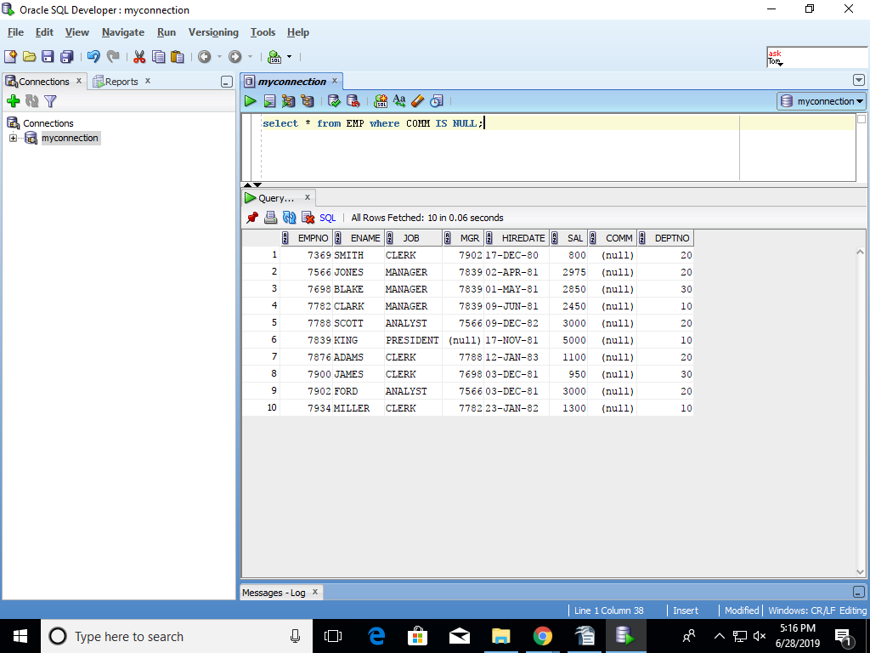
- List employees for whom COMM is applicable
select * from EMP where COMM IS NOT NULL;
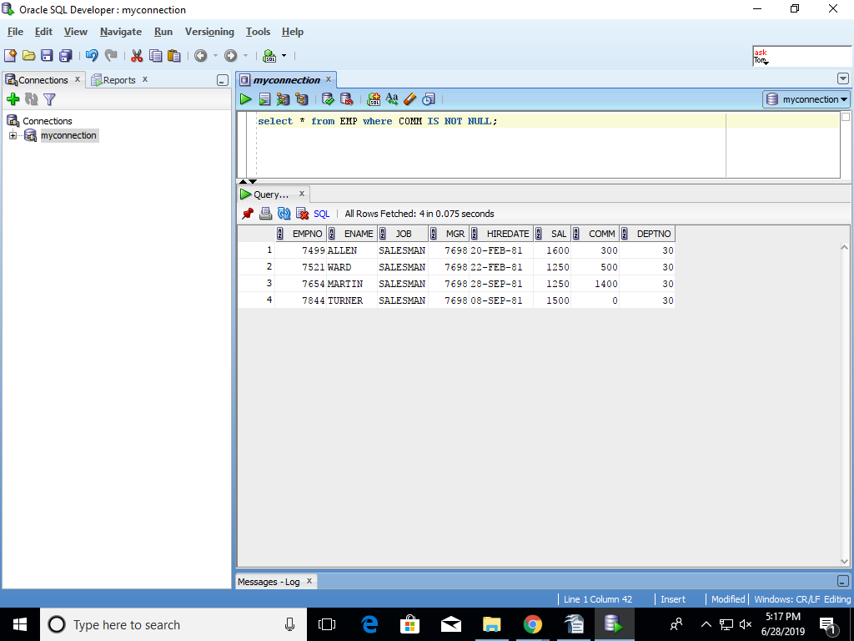

- List employees in ascending order of COMM and note how NULLs are sorted
SELECT * FROM EMP ORDER BY COMM;
NULLS ARE SORTED LIKE IN SALARY ONE INCRESE AND ONE DECREASE
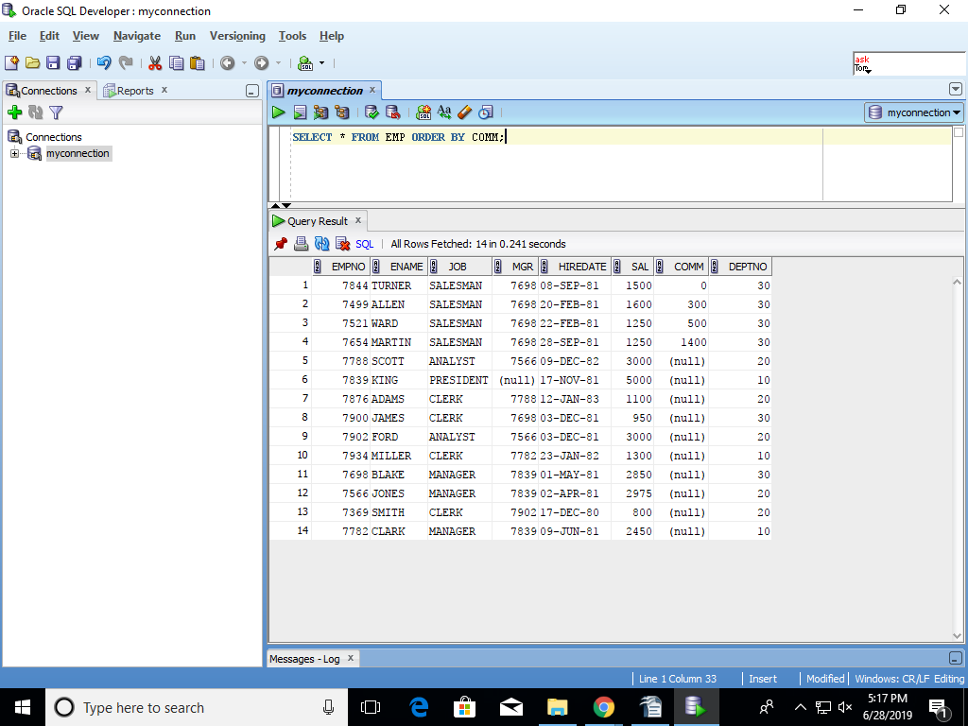

- List employees whose names start with ‘’SMITH’
SELECT ENAME from EMP where ENAME LIKE 'SMITH%';
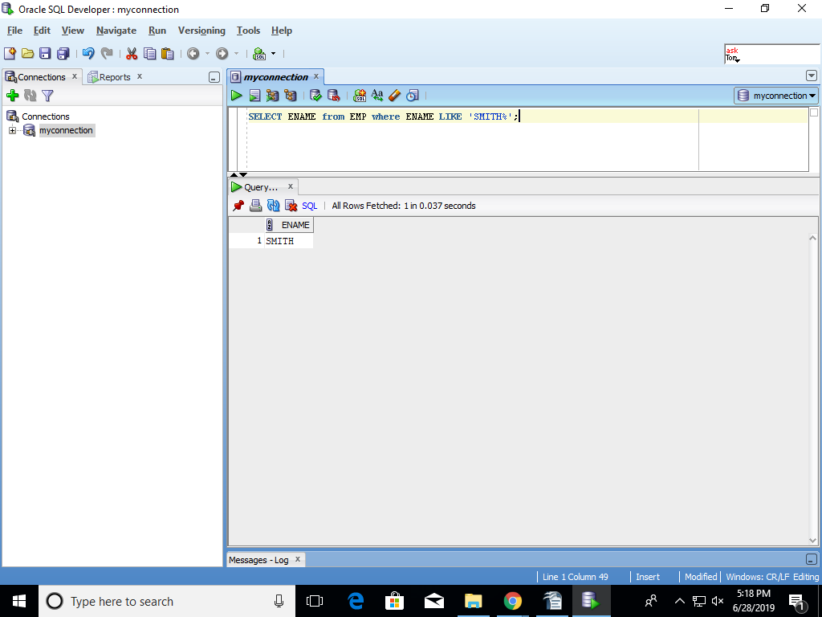

- List employees whose name contain the ‘MI’
SELECT ENAME from EMP where ENAME LIKE '%MI%';
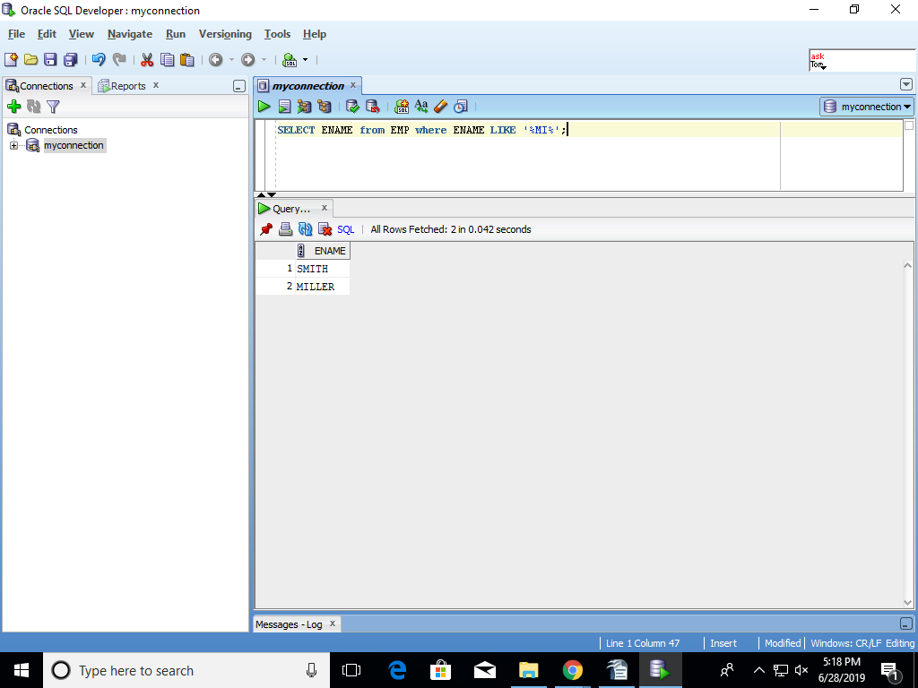

- List employees whose name start with an char.
Select ENAME from EMP where ENAME Like '%';
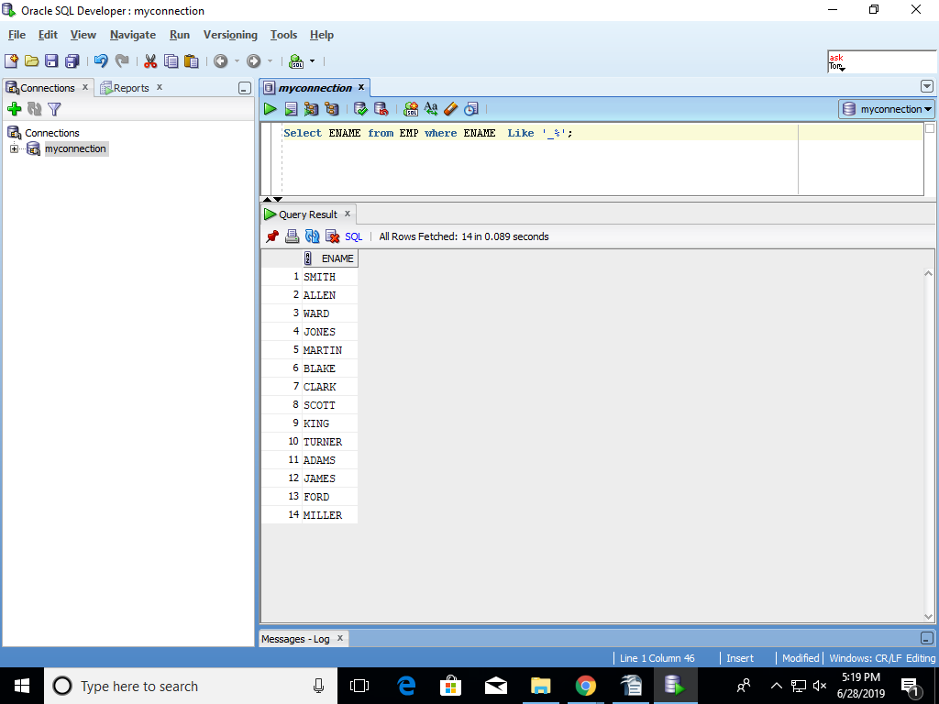

- List all employees joined between two given dates.
Select ENAME from EMP where HIREDATE='&HIREDATE'and HIREDATE='&HIREDATE';

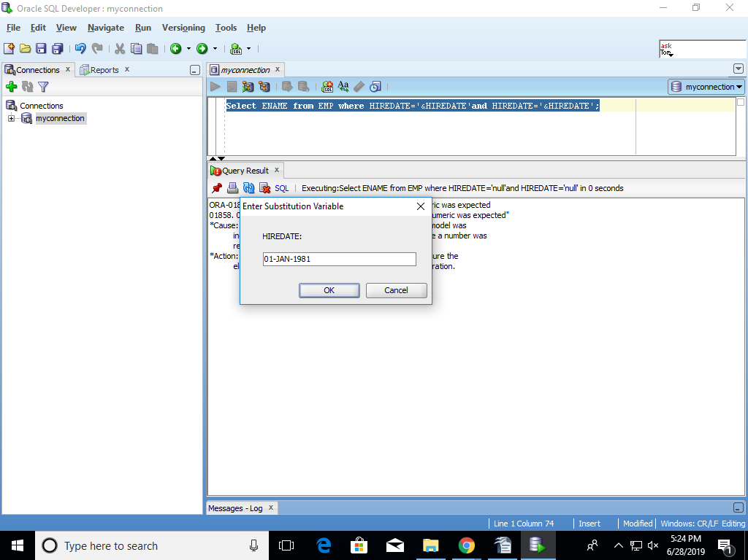

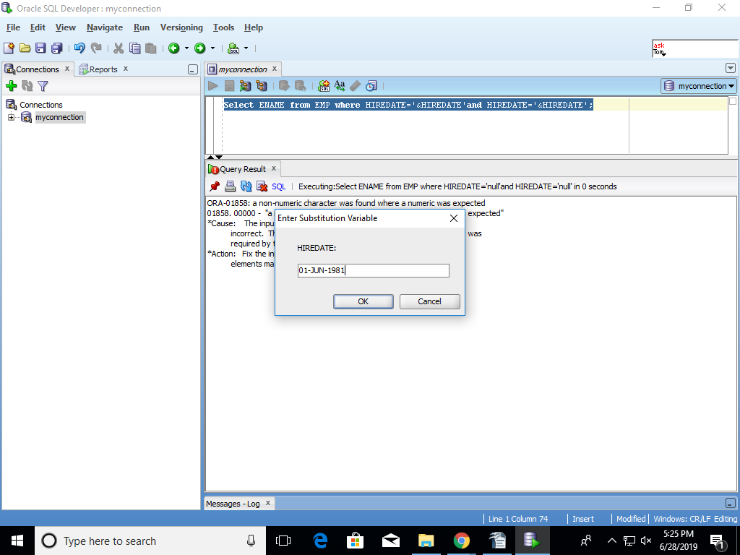

- List all clerks in deptno 10
select * from EMP WHERE JOB='CLERK' AND DEPTNO=10;
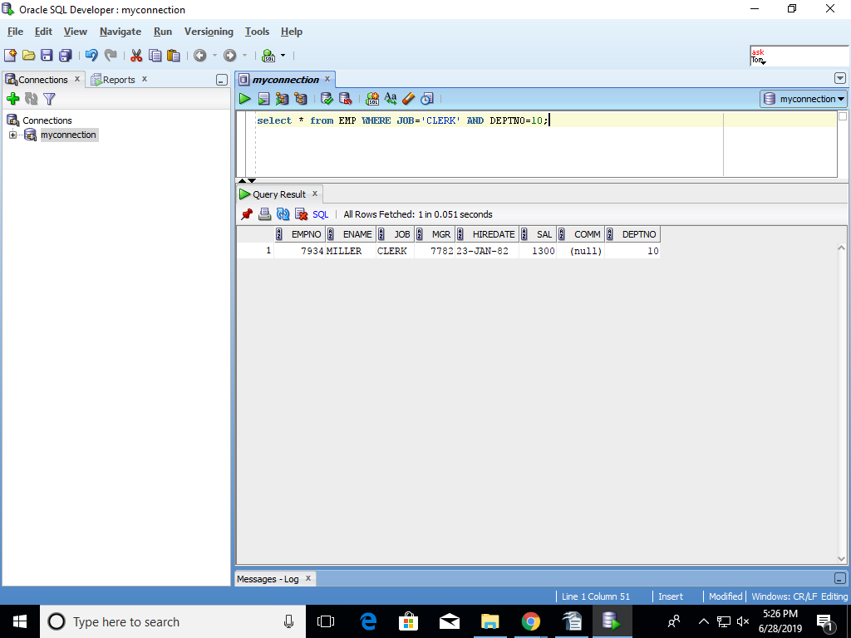

- List total/sum, maximum, minimum, average of salary from employee table
select MAX(SAL),MIN(SAL),AVG(SAL) from EMP;
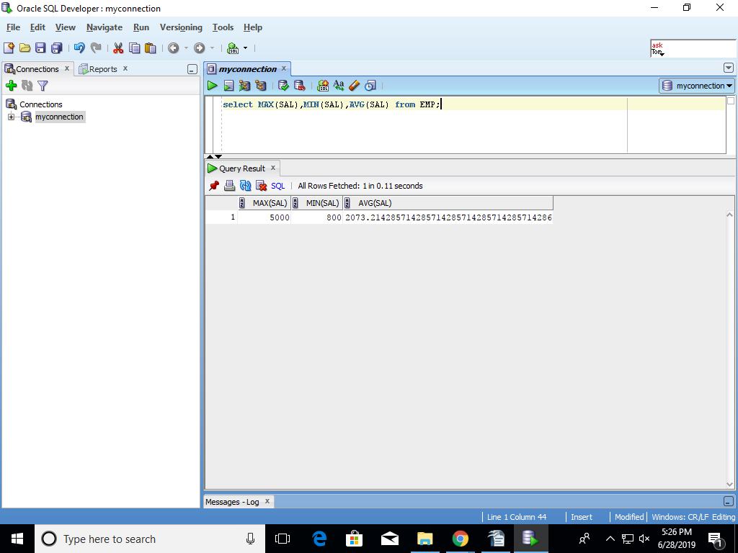

- List average and count of commission of all employees in department 10
select avg(COMM),count(COMM) from EMP where deptno=10;
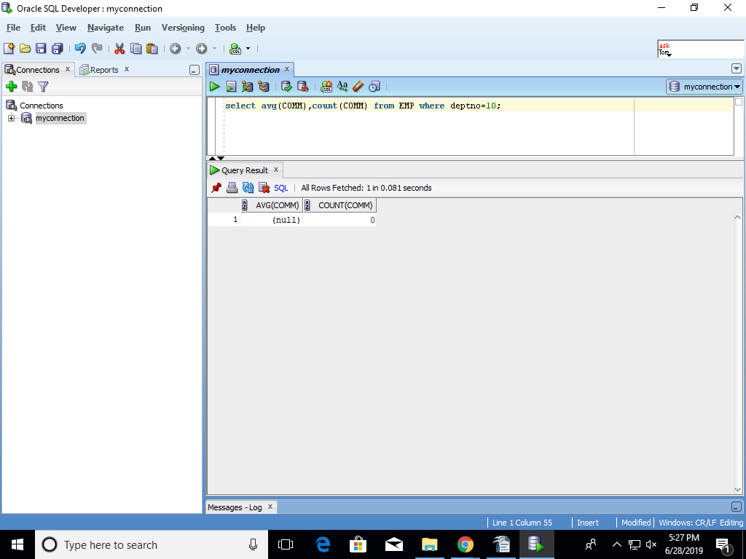

- List department wise no of employees and total salary
select count(EMPNO) from EMP group by DEPTNO;
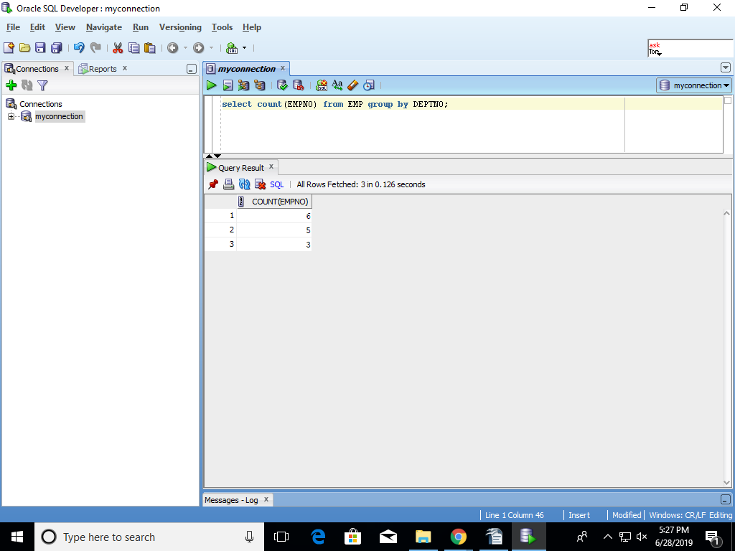

- List total salary Job wise within each department
select sum(SAL) from EMP GROUP BY DEPTNO;

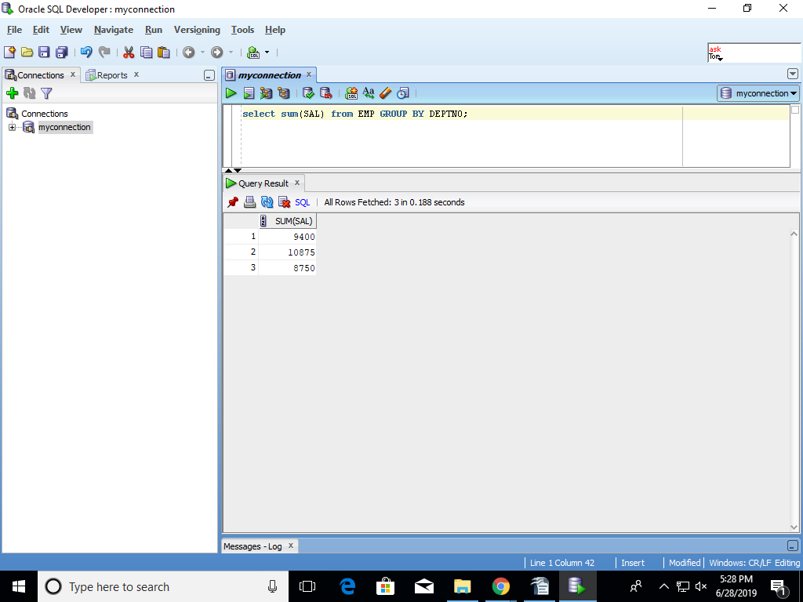

- List department wise total salary for deptno 10 and 20 only
select DEPTNO,sum(SAL) from EMP where DEPTNO=10 and DEPTNO=20 GROUP BY DEPTNO;
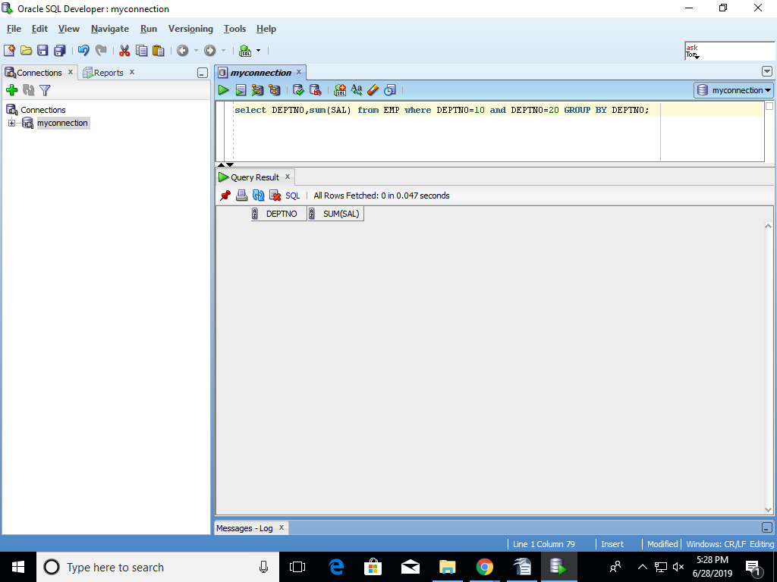
- List department wise total salary where total salary is > 6000
select sum(SAL) "TOTAL" FROM EMP where SAL>6000;
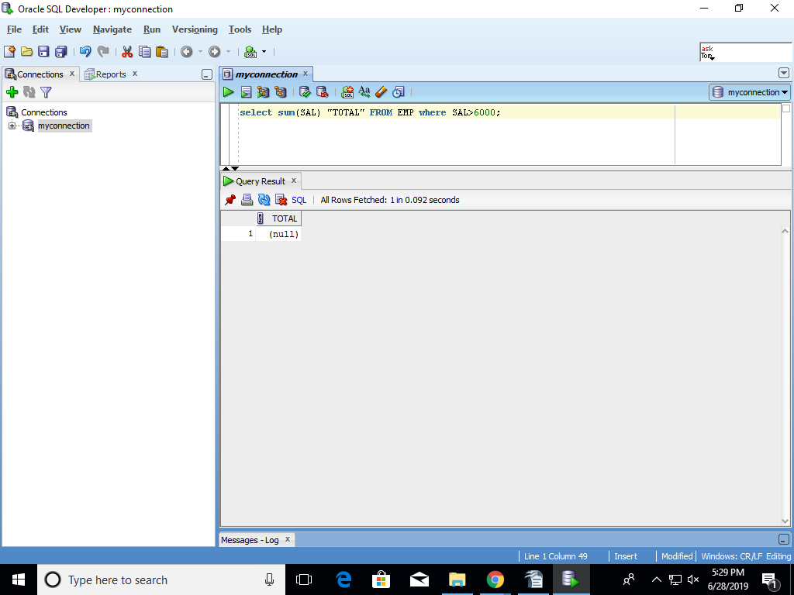
- SELECT COUNT(*), COUNT(COMM) FROM EMP; - explain why the two counts are different
COUNT(*)-will give all the information from EMP table
COUNT(COMM)-will give only count of comm
Sub Queries:
- List employees whose job is same as that of ‘SMITH’
select * from EMP where JOB=(select JOB from EMP where ENAME ='SMITH');
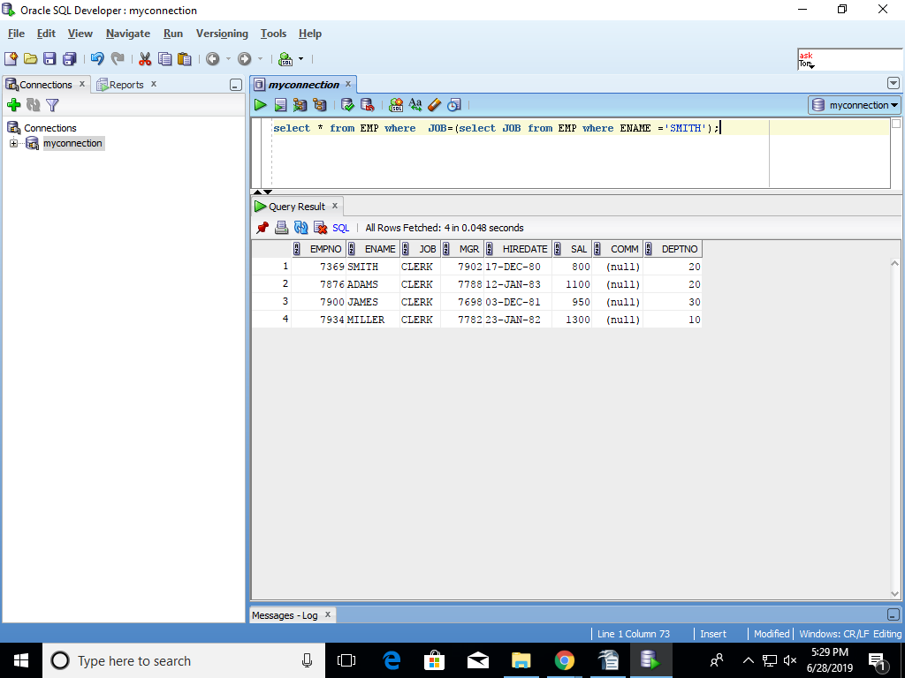

- List employees who have joined after ‘ADAM’
select ENAME from EMP where HIREDATE >(select HIREDATE from EMP where ENAME='ADAM');
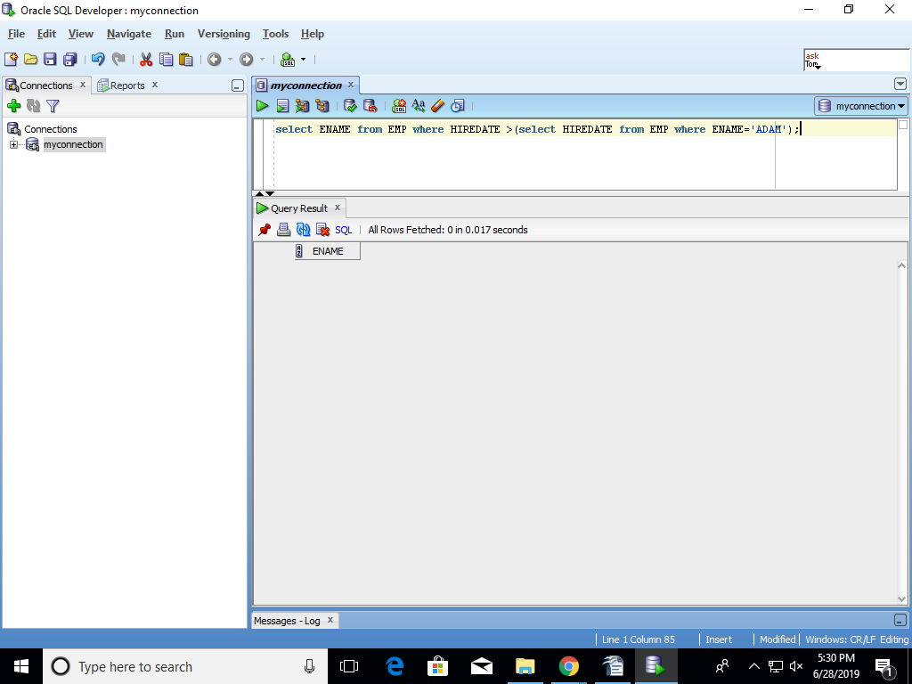
- List employees who salary is greater than ‘SCOTT’s salary
select * from EMP WHERE SAL>(select SAL from EMP where ENAME='SCOTT');

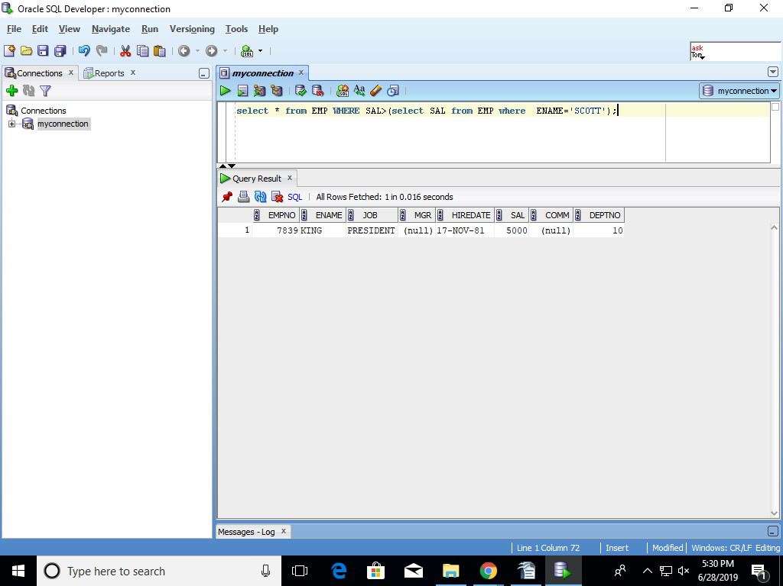

- List employees getting the maximum salary
select * from EMP where SAL =(select max(SAL) from EMP);
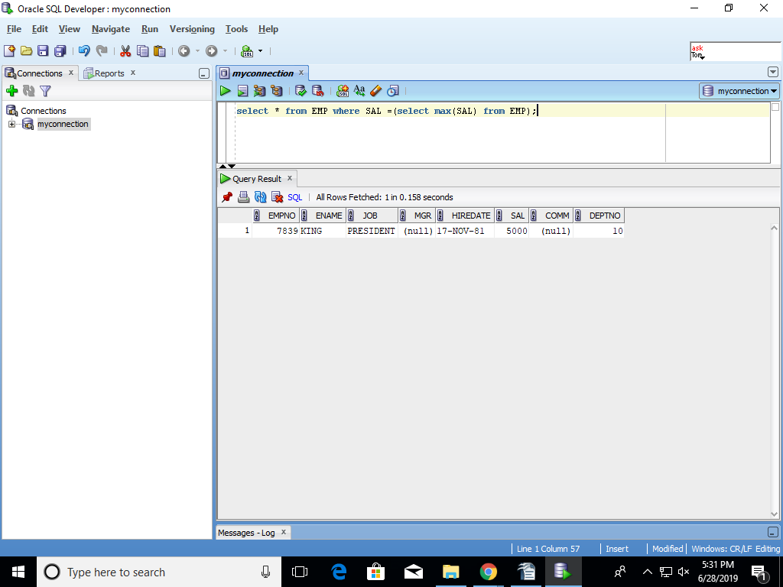

- List employees show salary is > the max salary of all employees in deptno 30
select * FROM EMP where sal> (select max(sal) FROM EMP where deptno=30);
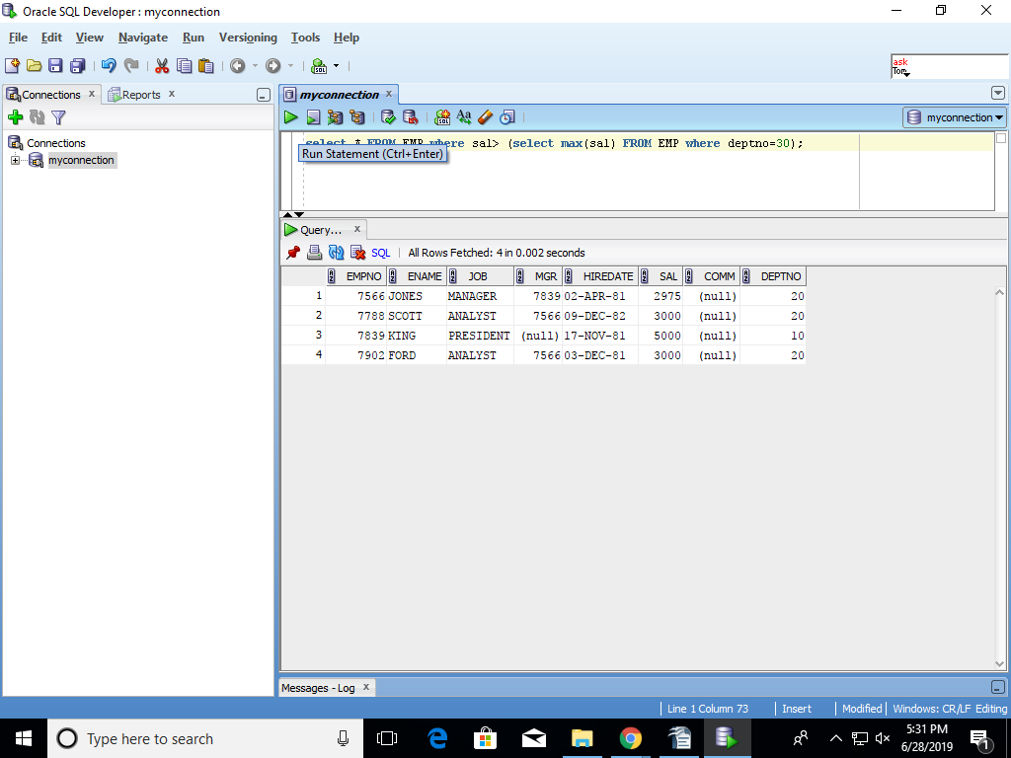

- List all employees whose deptno and Job are same as that of employee with empno 7788.
select * from EMP where DEPTNO LIKE(select DEPTNO from EMP where empno=7788) AND JOB LIKE(select JOB from EMP where empno=7788) ;
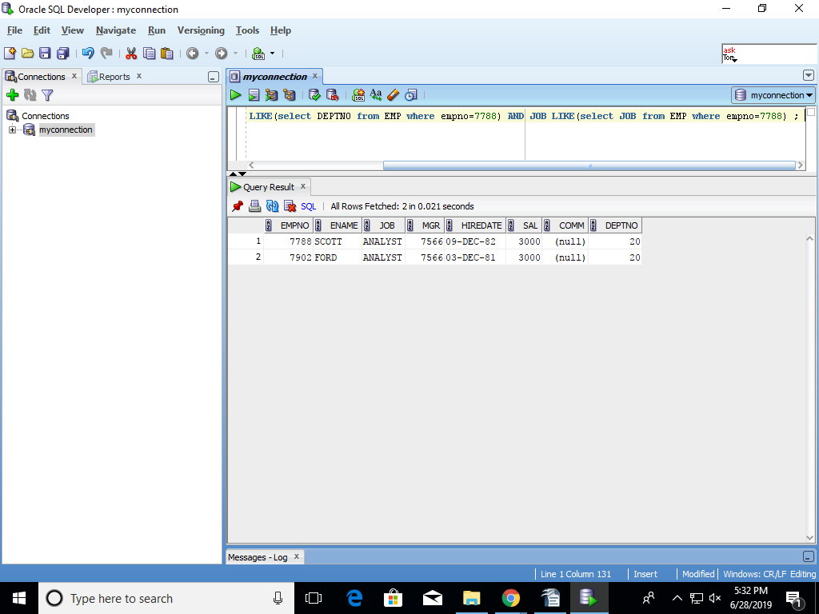

- List employee who are not managers
select * from EMP where empno NOT IN(select MGR from EMP);
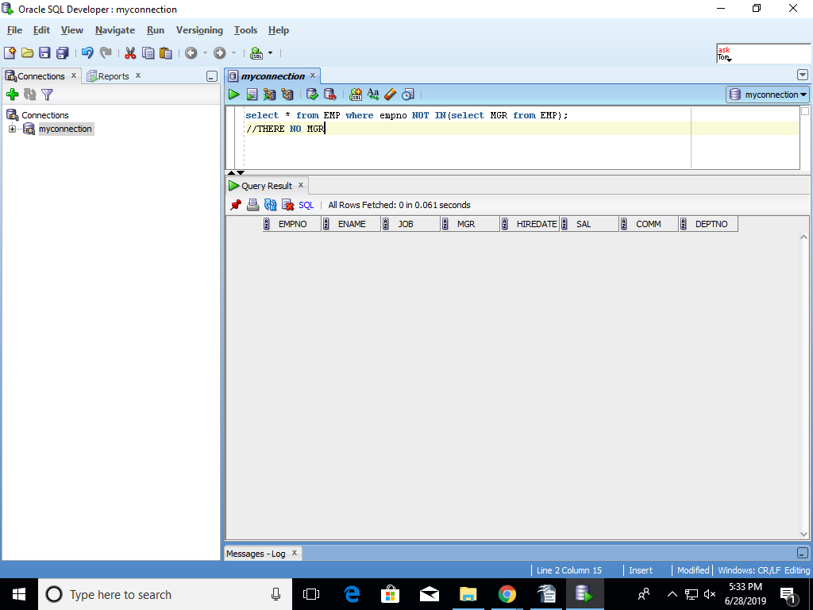

- List all managers
select * from EMP where job='MANAGER';
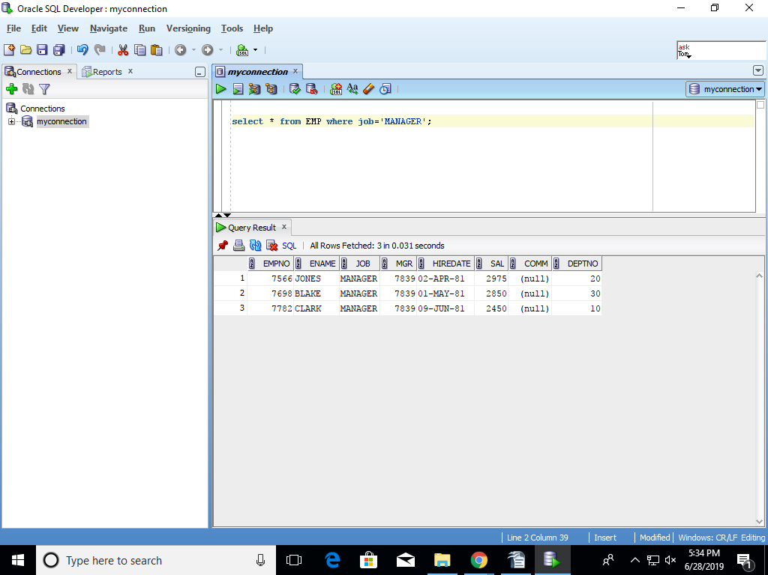

- List all employees who earn(salary) more than the average salary in their own department
select * from EMP where sal>(select avg(sal) from EMP );
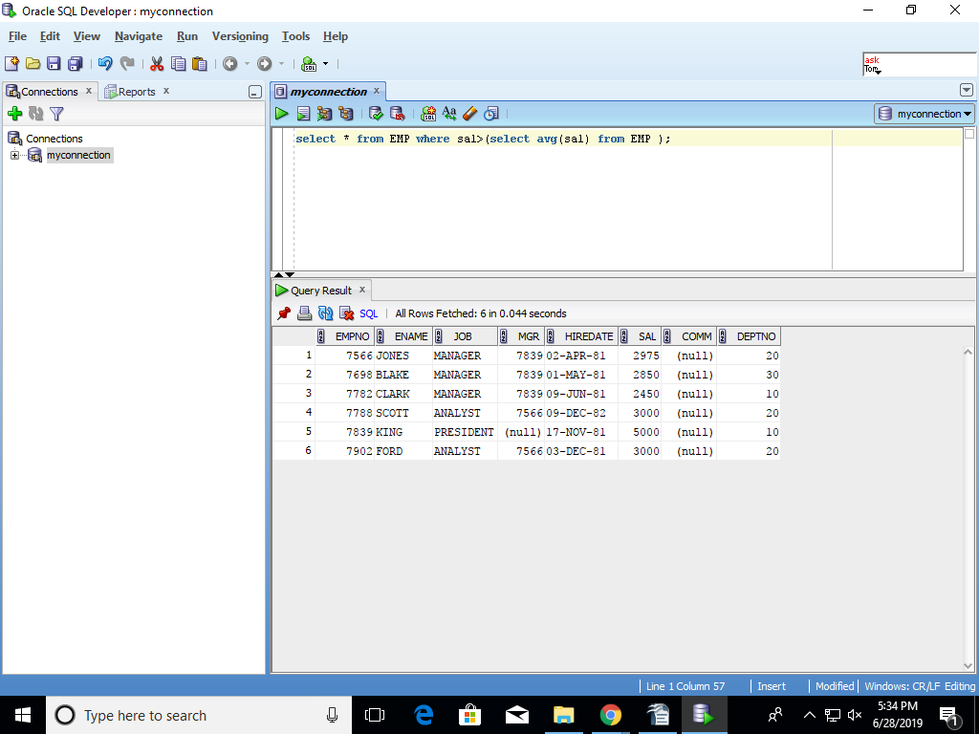

- List employees whose salary is greater than their manager’s salary
select * from emp w,emp m where w.mgr = m.empno and w.sal > m.sal ;
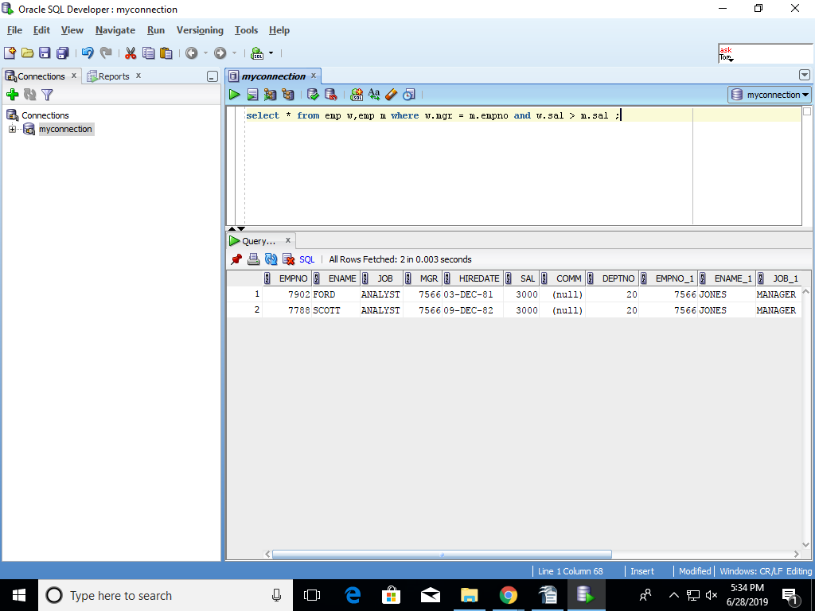

- List details of departments from DEPT table for which there are no employees in EMP table
SELECT DNAME FROM DEPT WHERE DEPTNO NOT IN(SELECT DEPTNO FROM EMP);
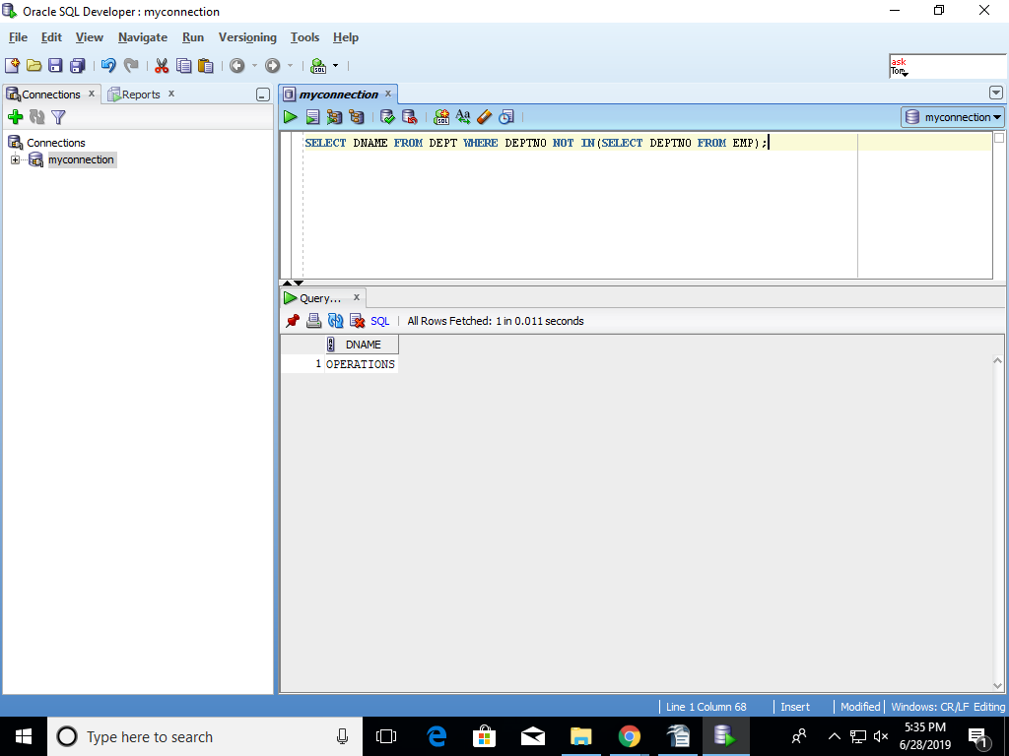
Module 2/Day 2
Joins:
- List employee name, department number and their corresponding department name by joining EMP and DEPT tables
select e.ename,d.deptno,dname from EMP e,DEPT d where e.deptno=d.deptno;
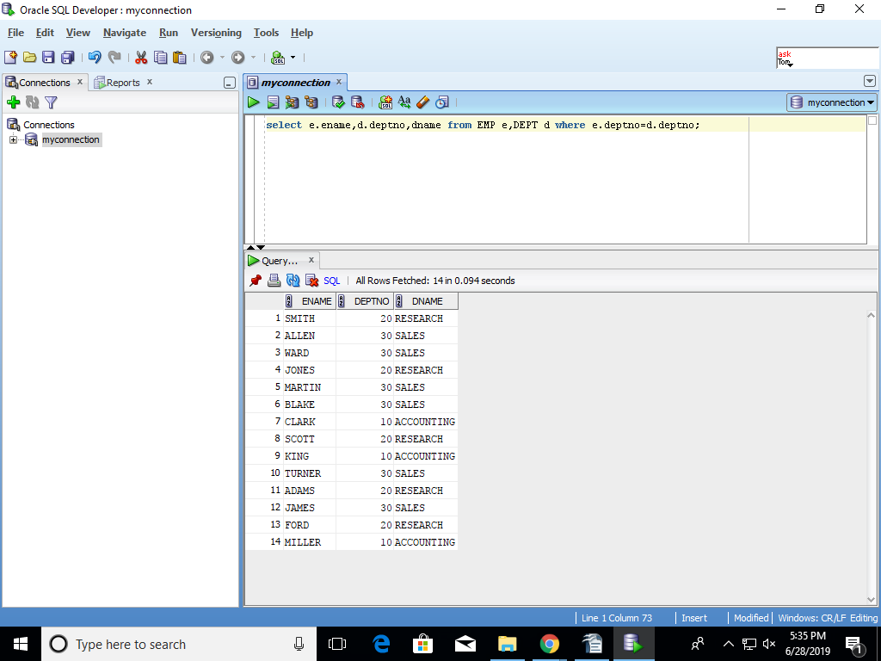

- List employee name and their manager name by joining EMP table to itself
SELECT DISTINCT e.EMPNO, e.ENAME FROM Emp e, Emp m WHERE e.DEPTNO = m.DEPTNO;

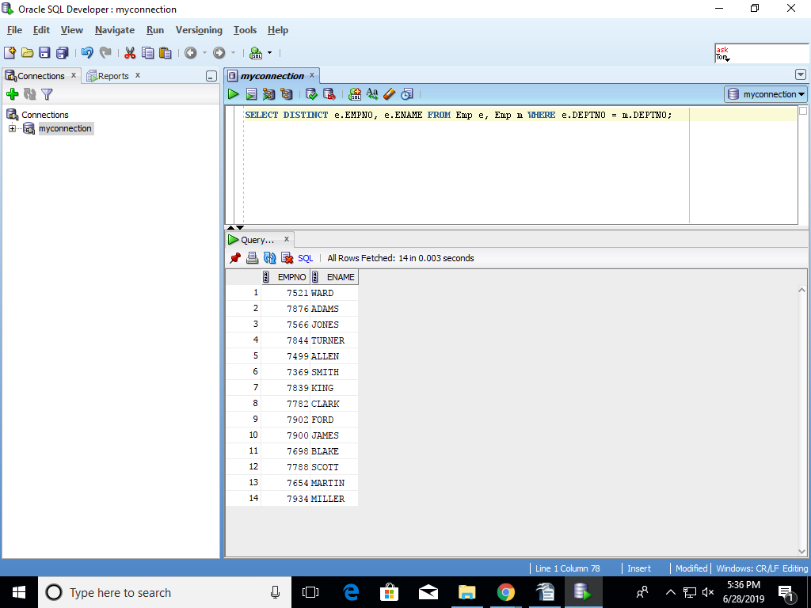

- List employee name, department name and their grade by joining EMP, DEPT and SALGRADE tables
SELECT E.ENAME,D.DNAME,S.GRADE FROM EMP E,DEPT D,SALGRADE S WHERE E.DEPTNO=D.DEPTNO;
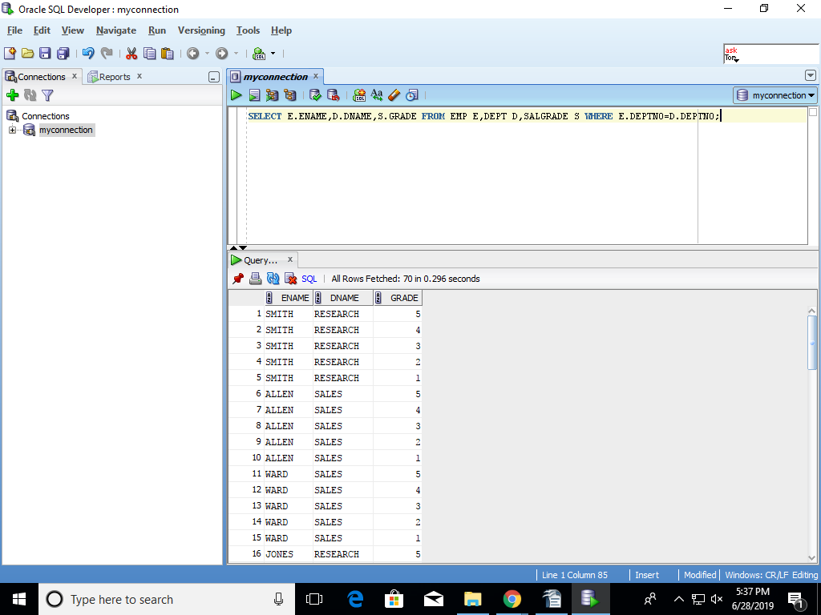

- List employees who work in ‘Research’ department by joining EMP and DEPT tables
SELECT E.ENAME FROM EMP E,DEPT D WHERE E.DEPTNO=D.DEPTNO AND JOB='RESEARCH' ;
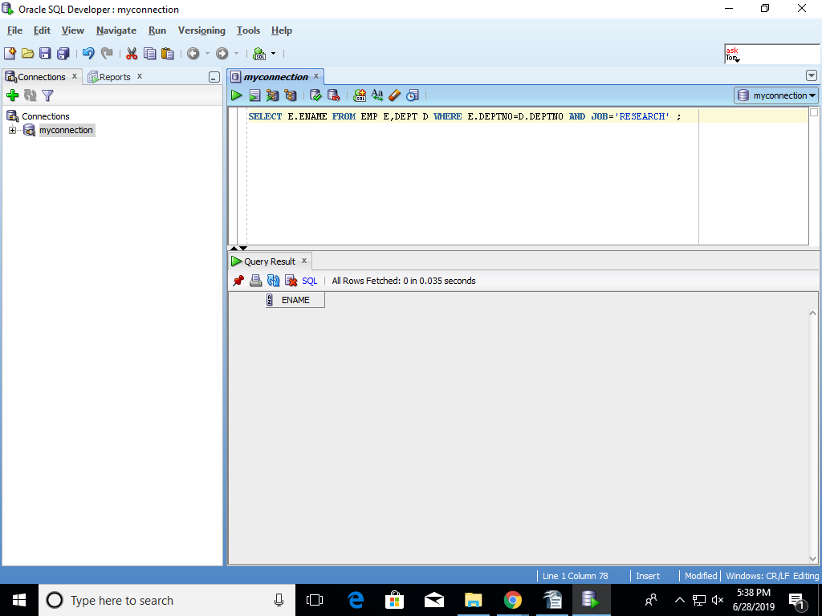

- List all rows from EMP table and only the matching rows from DEPT table – LEFT OUTER JOIN
SELECT * FROM EMP LEFT OUTER JOIN DEPT ON EMP.DEPTNO=DEPT.DEPTNO;
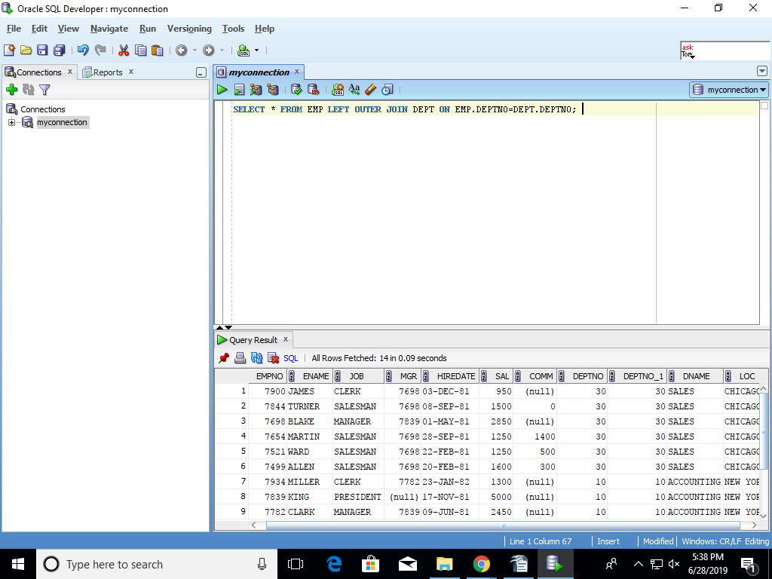
- List only matching rows from EMP table and all rows from DEPT table – RIGTH OUTER JOIN
SELECT * FROM EMP RIGHT OUTER JOIN DEPT ON EMP.DEPTNO=DEPT.DEPTNO;
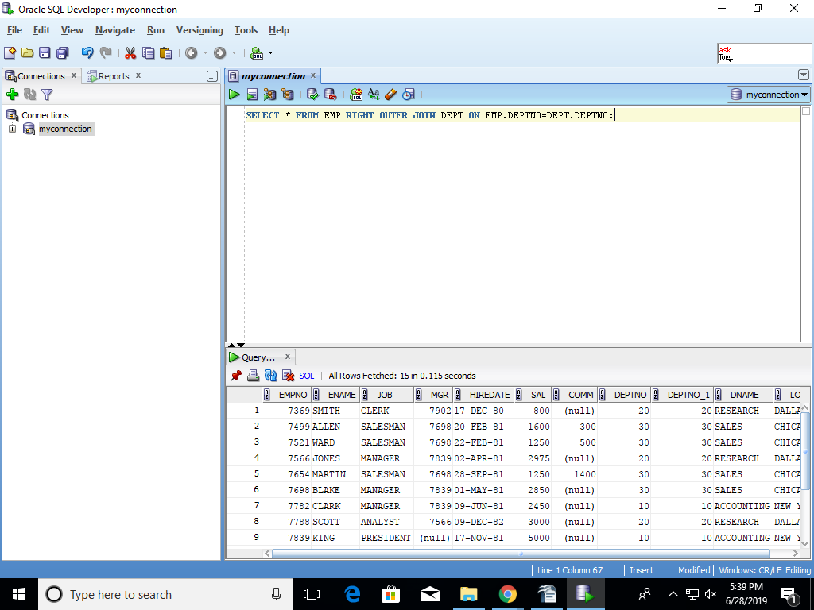

- Write a query to perform full outer join between EMP and DEPT tables
SELECT * FROM EMP FULL OUTER JOIN DEPT ON EMP.DEPTNO=DEPT.DEPTNO;
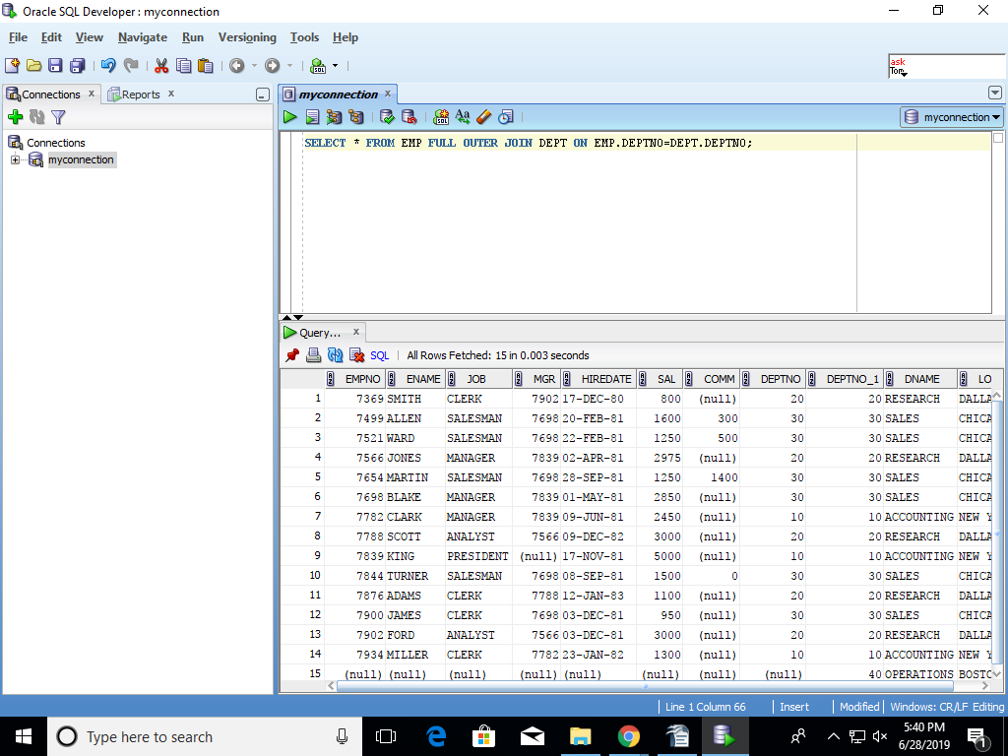

- List employee name, their manager name and their manager’s manager name

DDL
- Create DEPARTMENT table with the following columns with appropriate data type and width
  - Deptno PK
  - Danme
  - Location
CREATE TABLE DEPARTMENT
(Deptno NUMBER(10) NOT NULL PRIMARY KEY,
Dname VARCHAR2(9),
Location VARCHAR(10));

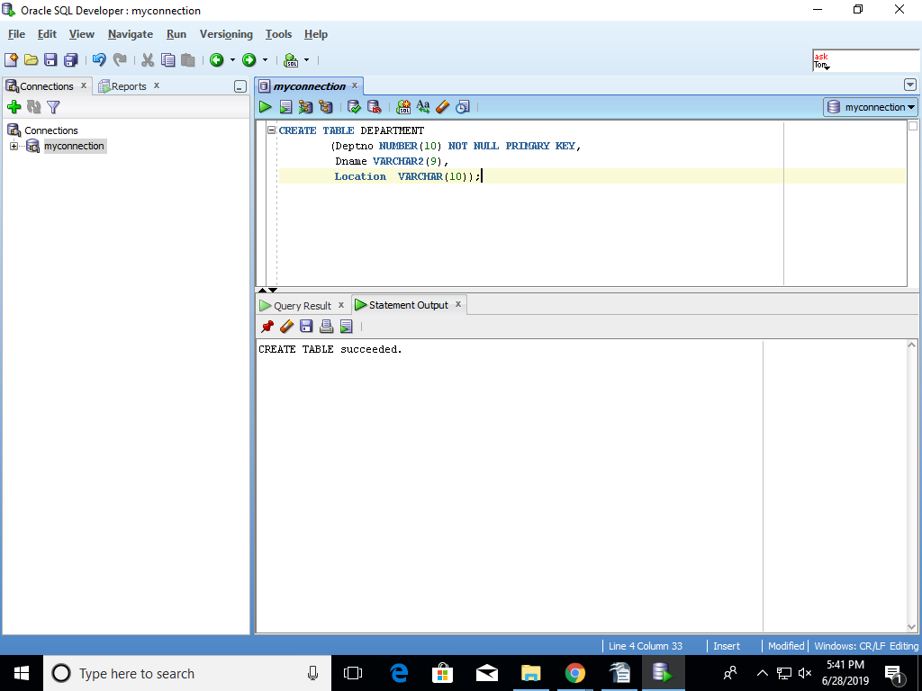

- Create EMPLOYEE table with the following columns with appropriate data type and width
  - empno PK
  - ename not null
  - designation
  - sex
  - basic_salary (> 0 and < 500000)
  - Date of joining
  - Deptno reference deptno of DEPARTMENT table
CREATE TABLE EMPLOYEE
(empno NUMBER(4) PRIMARY KEY,
ename VARCHAR2(10) NOT NULL,
designation VARCHAR2(9),
sex char(1),
basic_salary NUMBER(7, 2),
Date of joining DATE,
constraint fk_deptno foreign key (Deptno) references dept(deptno) );
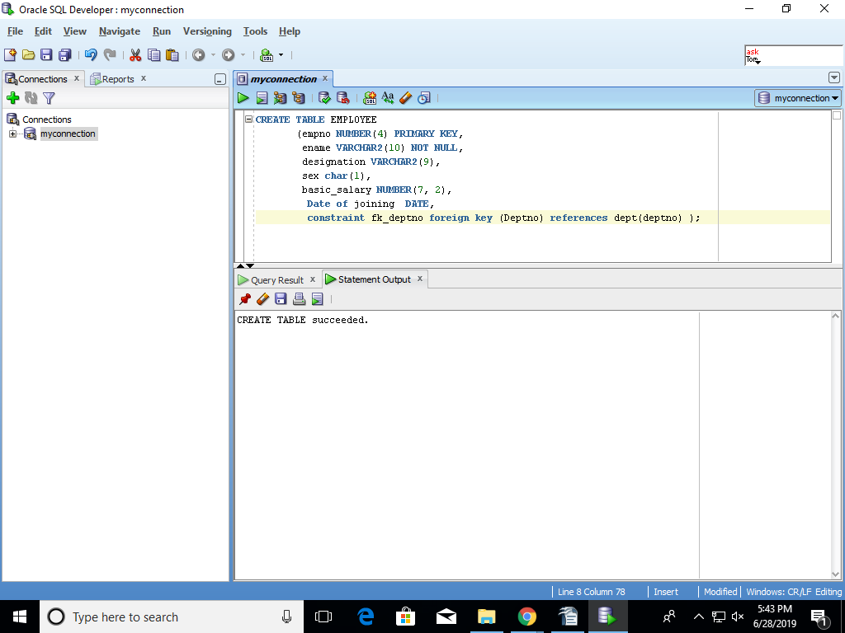

- Alter table EMPLOYEE add column commission
ALTER TABLE EMPLOYEE ADD COMMISION NUMBER(7,2);
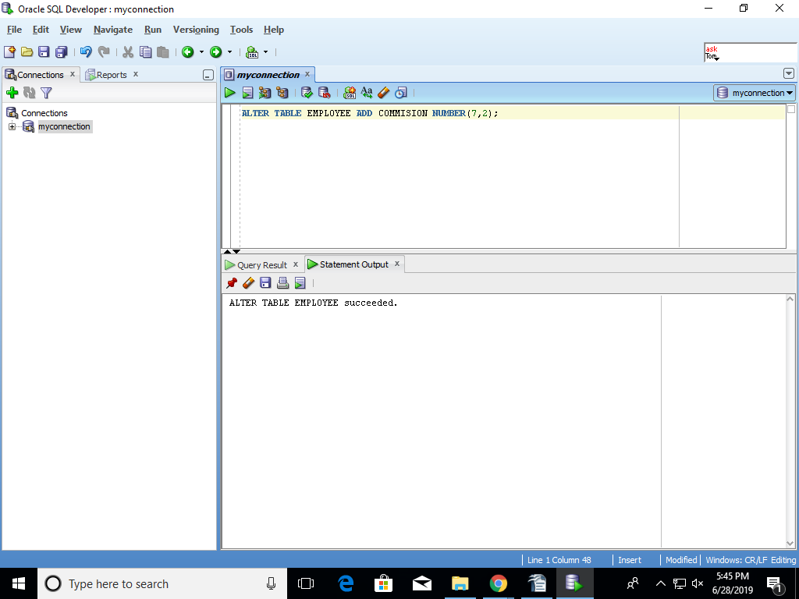

- Alter table EMPLOYEE add constraint SEX in (‘M’, ‘F’)
ALTER TABLE EMPLOYEE
ADD CONSTRAINT EMP_SEX
CHECK (SEX in ('M','F'));
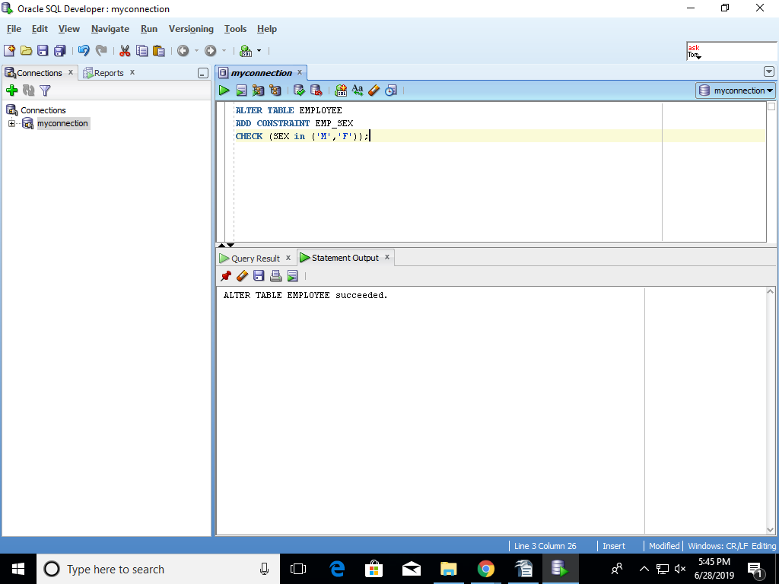

- Create Index on ename column of EMPLOYEE table
CREATE INDEX SNO ON EMPLOYEE(Ename);
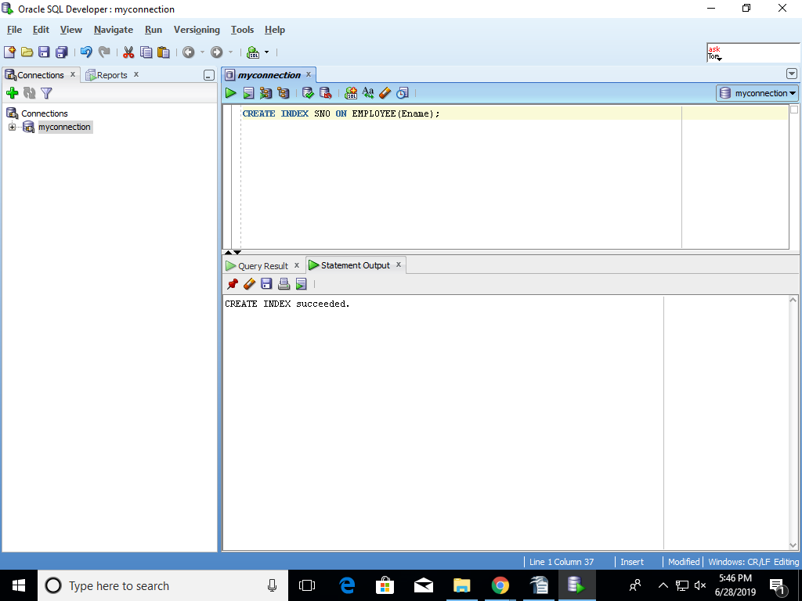

- Create exact replica of EMPLOYEE table with no data
create table EMPLOYEE1 as select * from EMPLOYEE;
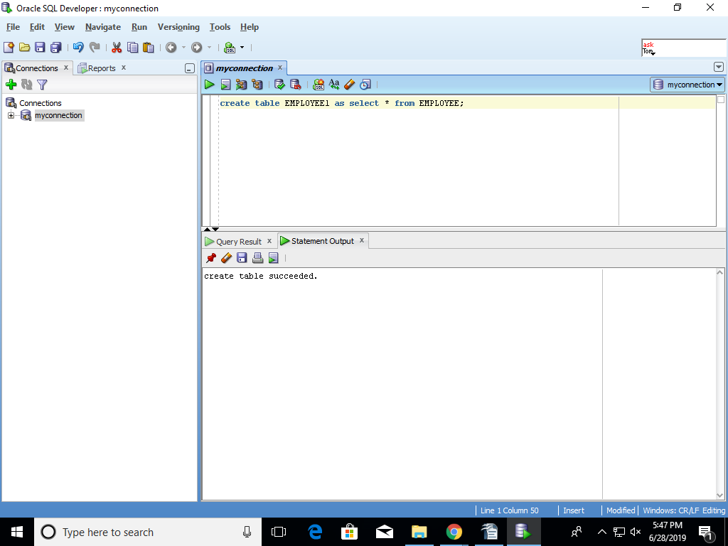

TRUNCATE TABLE EMPLOYEE1;
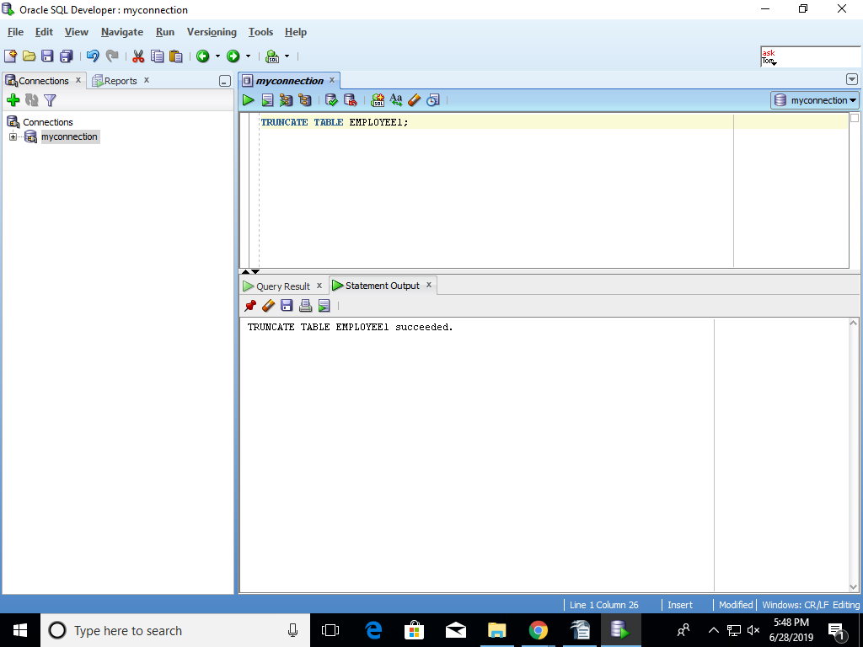

- Create new table called EX_EMP with columns empno, ename, basic_salary and populate the data from EMPLOYEE table
CREATE TABLE EX_EMP
(empno NUMBER(4) PRIMARY KEY,
ename VARCHAR2(10) NOT NULL,
basic_salary NUMBER(7, 2),
Dateofjoining DATE);
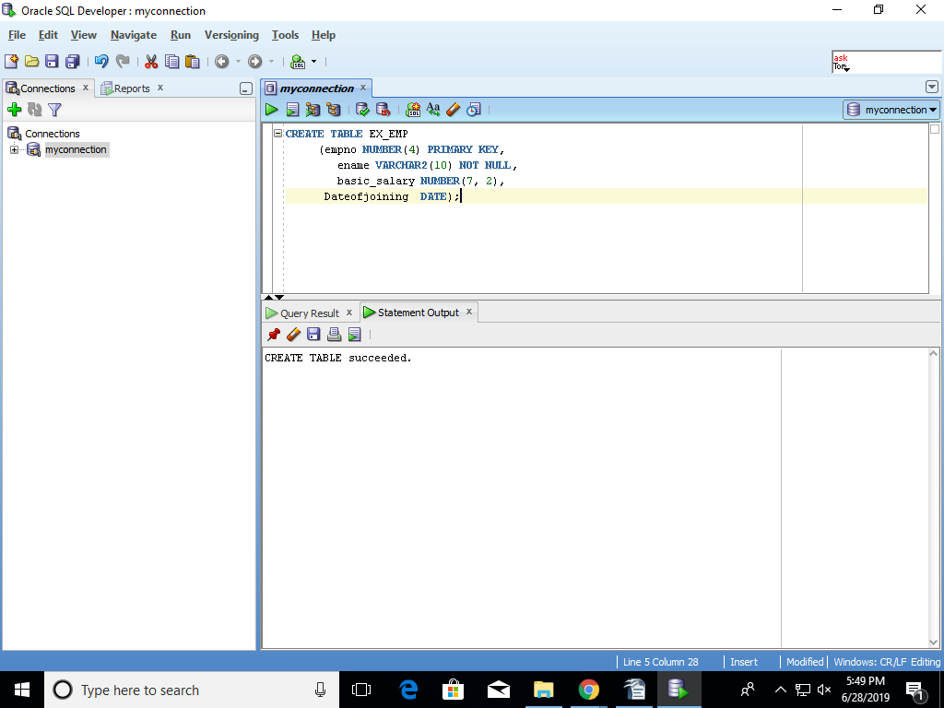

INSERT INTO EX_EMP(empno,ename,basic_salary)
        - SELECT empno,ename,sal FROM EMP;
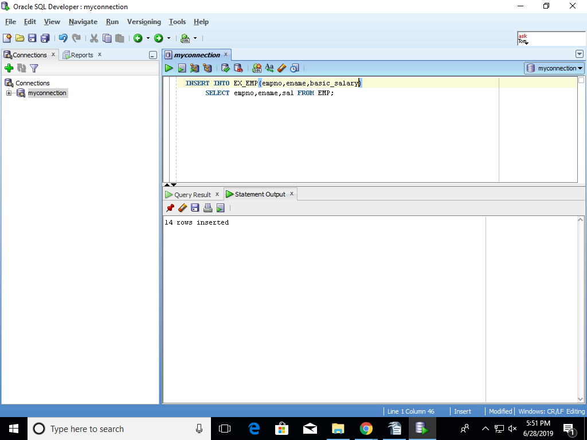

- Drop the Index created on ename column.
DROP INDEX SNO;
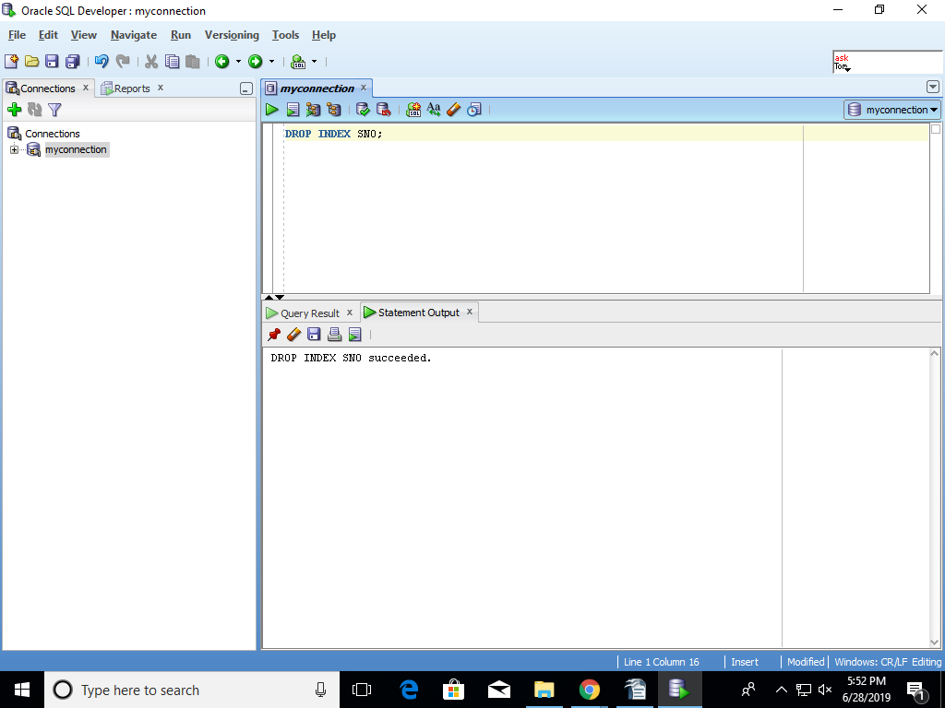

DML
- Insert at least 5 valid rows into DEPARTMENT table and commit the changes
INSERT INTO DEPARTMENT VALUES (1, 'ACCO', 'NEW YORK');
INSERT INTO DEPARTMENT VALUES (2, 'CLERK', 'DELHI');
INSERT INTO DEPARTMENT VALUES (3, 'HEALTH', 'DELHI');
INSERT INTO DEPARTMENT VALUES (4, 'THP', 'PUNE');
INSERT INTO DEPARTMENT VALUES (5, 'ANALY', 'HYD');
COMMIT;
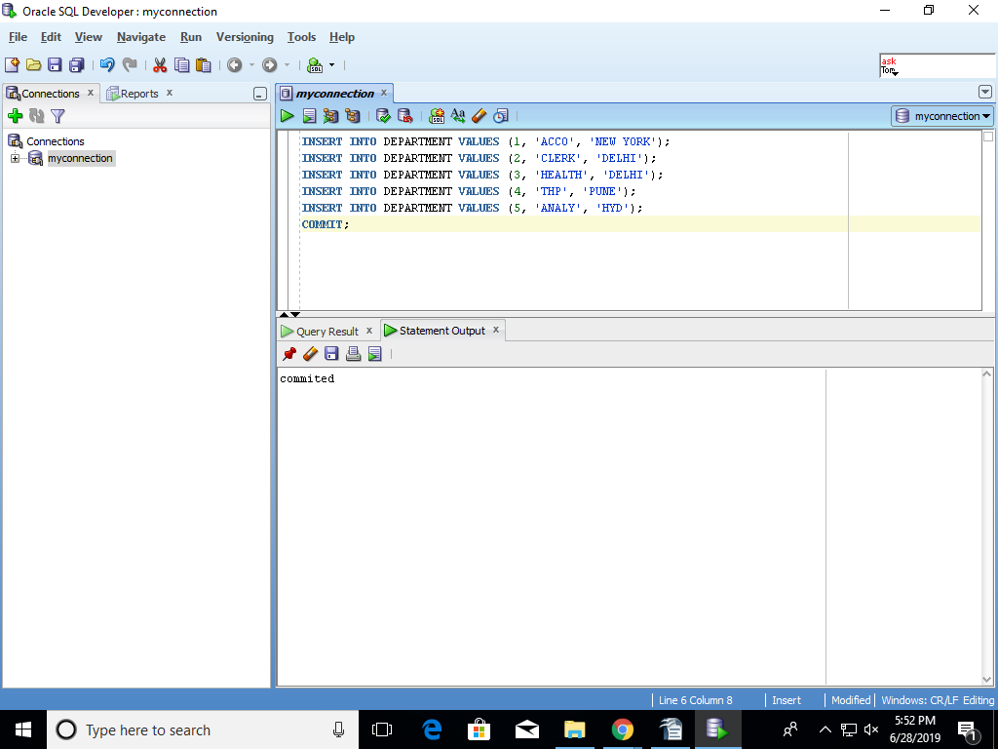
- Insert at least 15 valid rows in EMPLOYEE table and commit the changes
INSERT INTO EMPLOYEE VALUES (75, 'WARD', 'SALESMAN','F',1250,TO_DATE('22-FEB-1981', 'DD-MON-YYYY'), 3);
INSERT INTO EMPLOYEE VALUES(76, 'JAMES','SALE','M',1200,TO_DATE('01-DEC-1990', 'DD-MON-YYYY'), 2);
INSERT INTO EMPLOYEE VALUES(77, 'HONEY','CLERK','F',1209,TO_DATE('09-JAN-1999', 'DD-MON-YYYY'), 1);
INSERT INTO EMPLOYEE VALUES(78, 'LUSY','SALE','M',1500,TO_DATE('01-MAY-1986', 'DD-MON-YYYY'), 6);
INSERT INTO EMPLOYEE VALUES(79, 'MARTIN','HEALTH','F',1860,TO_DATE('22-DEC-1998', 'DD-MON-YYYY'), 7);
INSERT INTO EMPLOYEE VALUES(80, 'RAVINDAR','MANAGER','M',1100,TO_DATE('06-NOV-1999', 'DD-MON-YYYY'), 8);
INSERT INTO EMPLOYEE VALUES(81, 'PRADEEP','SALE','M',1200,TO_DATE('11-DEC-1990', 'DD-MON-YYYY'),9 );
INSERT INTO EMPLOYEE VALUES(82, 'HARISH','SALEEXECUTIVE','M',1200,TO_DATE('21-NOV-1990', 'DD-MON-YYYY'), 5);
INSERT INTO EMPLOYEE VALUES(83, 'LAKSHAMAN','MANAGER','M',1200,TO_DATE('26-NOV-1990', 'DD-MON-YYYY'), 6);
INSERT INTO EMPLOYEE VALUES(84, 'REVANTH','SALE','M',1200,TO_DATE('03-DEC-1999', 'DD-MON-YYYY'), 1);
INSERT INTO EMPLOYEE VALUES(85, 'SRINU','SALEEXECUTIVE','M',1200,TO_DATE('31-JAN-1990', 'DD-MON-YYYY'), 2);
INSERT INTO EMPLOYEE VALUES(86, 'JYOTHI','MANAGER','F',1200,TO_DATE('11-MAY-1991', 'DD-MON-YYYY'), 3);
INSERT INTO EMPLOYEE VALUES(87, 'MANASA','SALE','F',1200,TO_DATE('01-JAN-1990', 'DD-MON-YYYY'), 7);
INSERT INTO EMPLOYEE VALUES(88, 'KALYANI','SALEEXECUTIVE','F',1200,TO_DATE('01-DEC-1990', 'DD-MON-YYYY'), 8);
INSERT INTO EMPLOYEE VALUES(89, 'HON','MANAGER','M',1200,TO_DATE('01-DEC-1990', 'DD-MON-YYYY'), 4);
COMMIT;
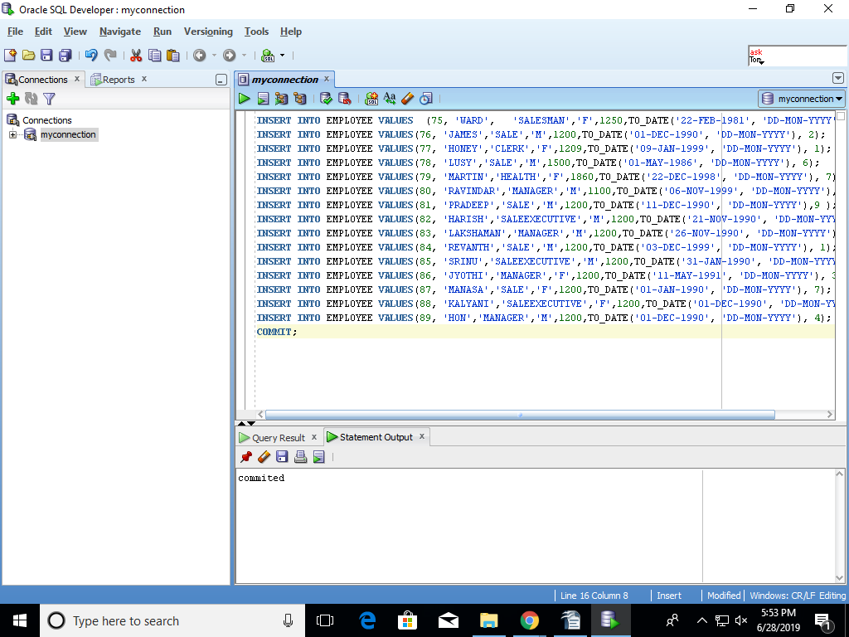

- Update basic_salary by 10% for employees in deptno 10 and 20 and commit the changes
update EMPLOYEE
set basic_salary = case
when deptno= 1 then basic_salary * 10
when deptno = 2 then basic_salary * 10
else basic_salary
end
where deptno in(1,2);
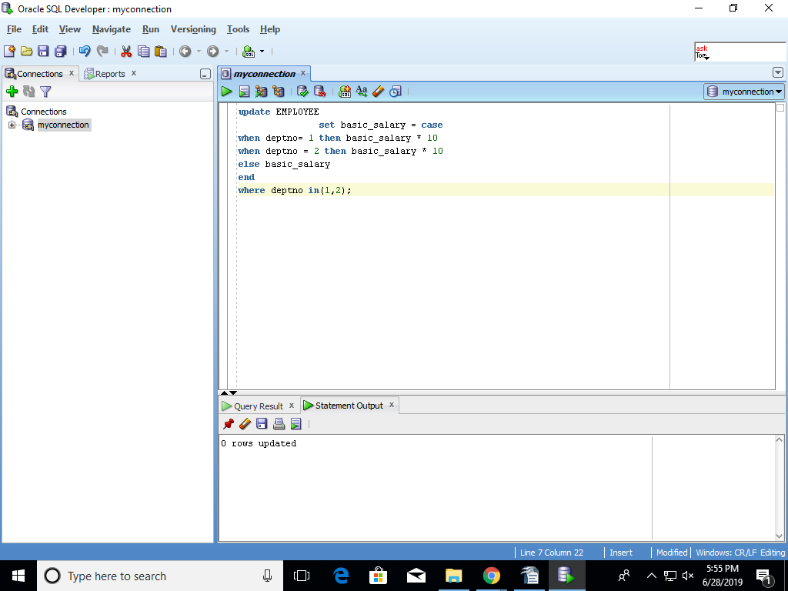

- Update basic_salary and commission by 10% and 2% for all employees for whom commission is currently applicable and commit the changes
update EMPLOYEE set basic_salary and commission=case
when commission is not null then basic_salry*10; and commission*10;
else basic_salary,commision
end;
COMMIT;
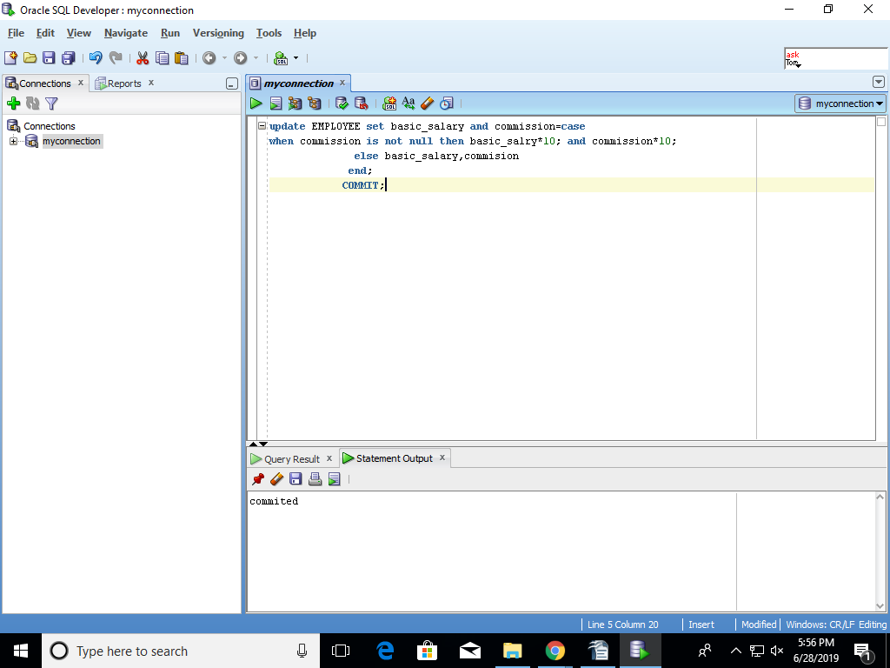

- Update the designation of given employee to MANAGER based of given employee number and commit the changes.
Update EMPLOYEE set designation='MANAGER' WHERE EMPNO='&EMPNO';
COMMIT;
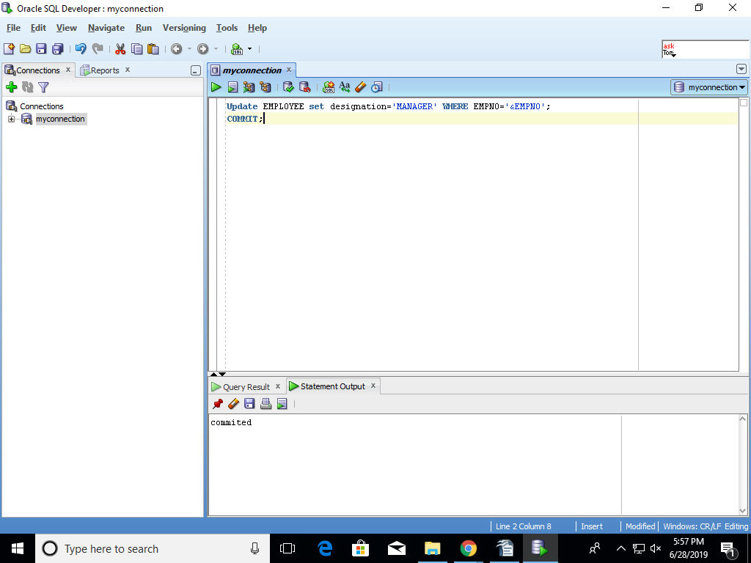

- Delete employees joined before a given year and commit changes
DELETE FROM EMPLOYEE WHERE dateojoining<('&dateofjoining');
commit;
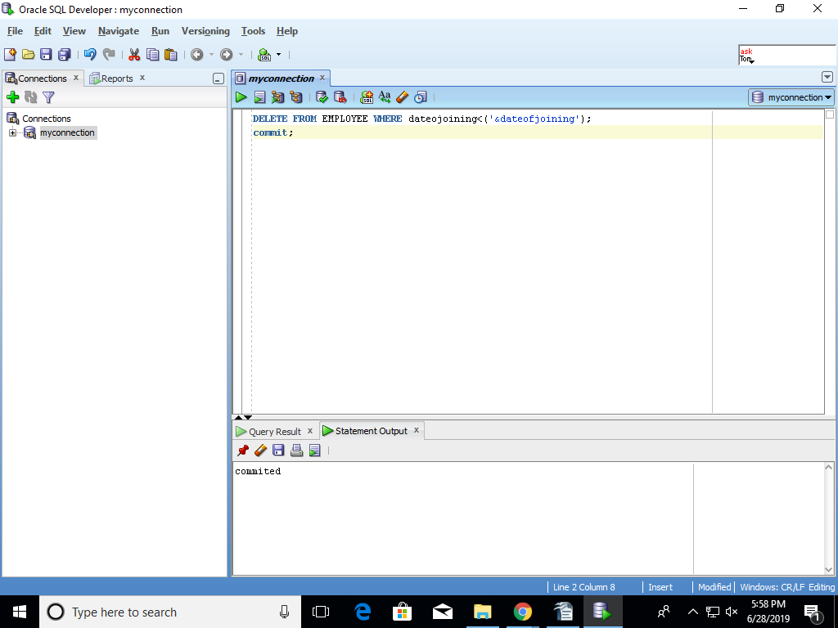
- Delete all rows from employee tables.
drop table employee;
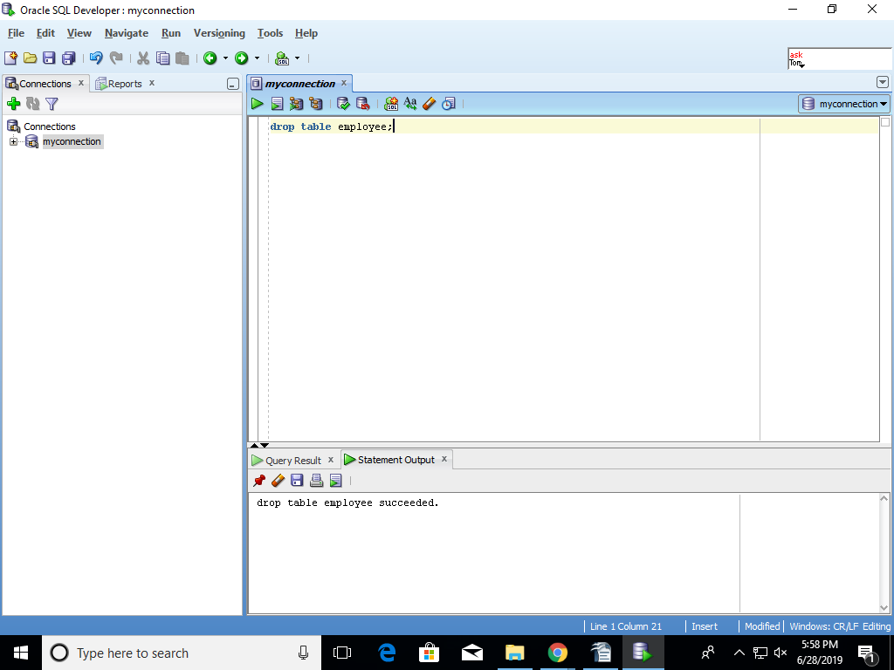

- Query employee table
select * from employee;
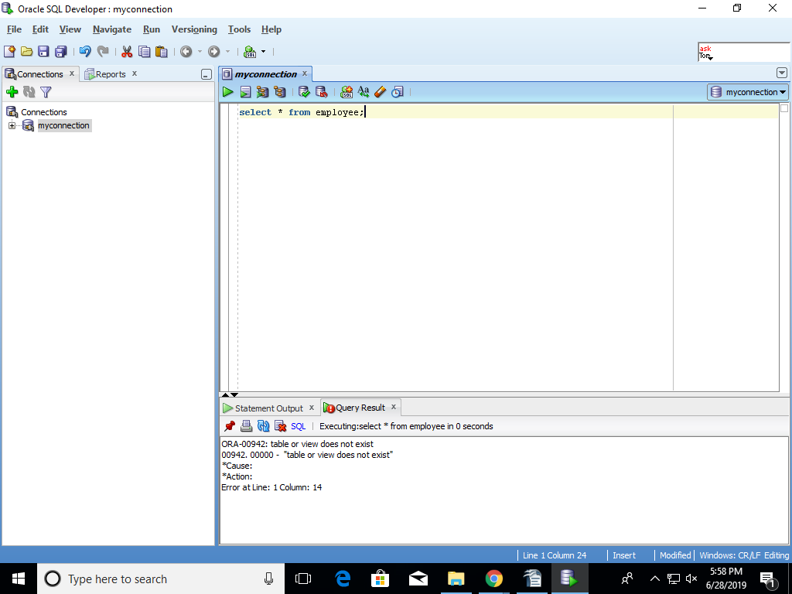

- ROLLBACK
INSERT INTO EMPLOYEE VALUES(85, 'SRINU','SALEEXECUTIVE','M',1200,TO_DATE('31-JAN-1990', 'DD-MON-YYYY'), 2);
DELETE FROM EMPLOYEE WHERE ENAME='SRINU';
ROLLBACK;
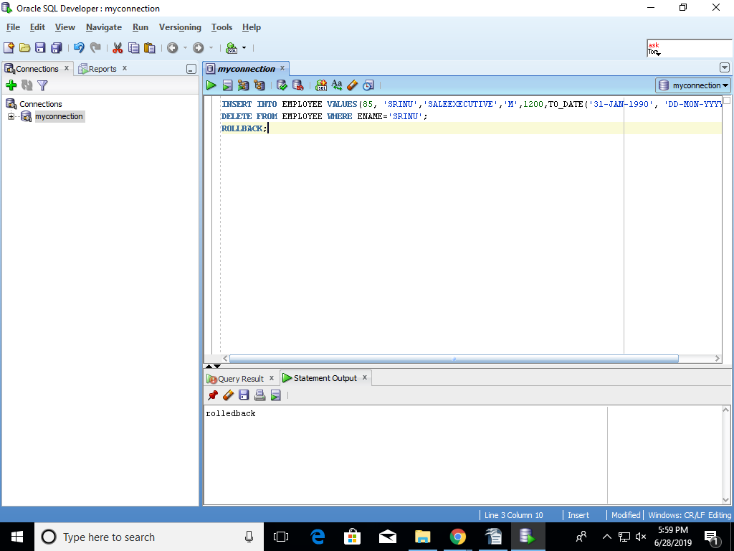

- Query employee table
SELECT ENAME FROM EMP;
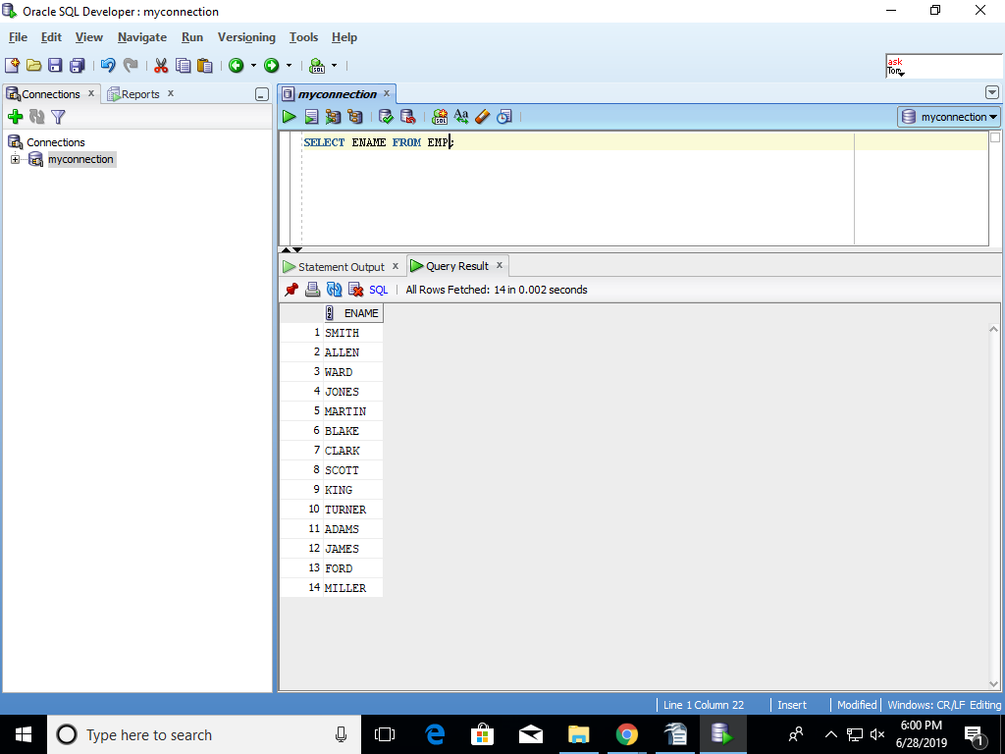

- Delete all rows from employee tables permanently using appropriate DDL command
TRUNCATE TABLE EMP;
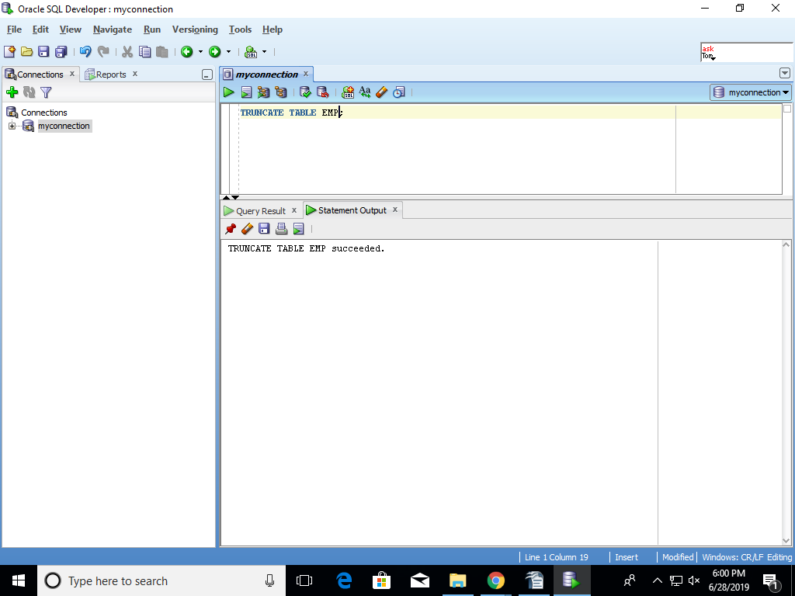

Procedure and Functions:
- Create a procedure named DISP_EMP_DETAILS with 3 parameters → one [ie. iEmpNo ] is an “IN” mode and other two are [ie. sGrade and sSalary] “OUT” mode parameters. The procedure should retrieve the Grade (this is column of SALGRADE table) and Salary for the specified employee number [ie. iEmpNo ] by joining EMP and SALGRADE table and assign the retrieved values to the “OUT” mode parameters.
Note:
It should display an appropriate error message if the specified employee number
does not exist in “Employee” table.
Call the created procedure using Bind variable and print the details.
CREATE OR REPLACE PROCEDURE DISP_EMP_DETAILS
DECLARE
(IEMPNO IN EMPLOYEE.EMPNO%TYPE,
SGRADE OUT EMPLOYEE.GRA%TYPE,
SSALARY OUT EMPLOYEE.SAL%TYPE) IS
BEGIN
SELECT GRA,SAL INTO SGRADE,SSALARY
FROM EMP E,SALGRADE S
WHERE EMPNO=IEMPNO AND E.EMPNO=S.EMPNO;
END DISP_EMP_DETAILS;
SET SERVEROUTPUT ON
DECLARE
V_GRA EMPLOYEE.GRA%TYPE;
V_SAL EMPLOYEE.SAL%TYPE;
BEGIN
DISP_EMP_DETAILS(171,V_GRA,V_SAL);
IF EMPNO !=IEMPNO
THEN DBMS.OUPUT.PUT_LINE('employee number does not exist');
ELSE DBMS.OUTPUT.PUT_LINE(V_GRA||'GRA'||TO_CHAR(V_SAL,'$999,999.00'));
END;
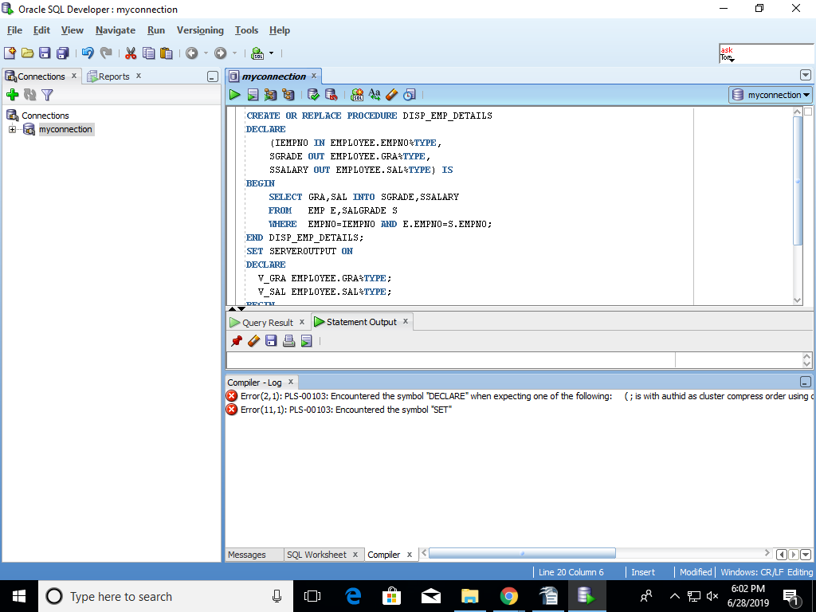

// I have tried these pl sql quaries but I got errors.

- Create a procedure named DISPLAY_RECORDS which accepts the P_JOB as a parameter and display all the employees (empno, sal, deptno, job) from the “EMP” table matching the given P_JOB in the following format :-

Employee Number Salary Department Number Job

XXXXXXXX 99,999 99 CLERK
XXXXXXXX 9,999 12 CLERK
Note:
It should display an appropriate error message if there are no employees with the given JOB
CREATE OR REPLACE PROCEDURE DISPLAY_RECORDS(JOB OUT EMPLOYEE.EJOB%TYPE)
TEMP VARCHAR2(10);
BEGIN
SELECT empno, sal, deptno, job
INTO TEMP
FROM EMPLOYEE
WHERE JOB=EJOB
IF(EJOB=JOB)
IF DEPTNO=99 THEN DBMS.OUTPUT.PUT_LINE(XXXXXXXX,'$99,99999',CLERK);
ELSIF DEPTNO=12 THEN DBMS.OUTPUT.PUT_LINE(XXXXXXXX,'$9,999',CLERK);
ELSE DBMS.OUPUT.PUT_LINE('THERE ARE NO EMPLOYEES WITH IN GIVEN JOB');
ENDIF
ENDIF
END;
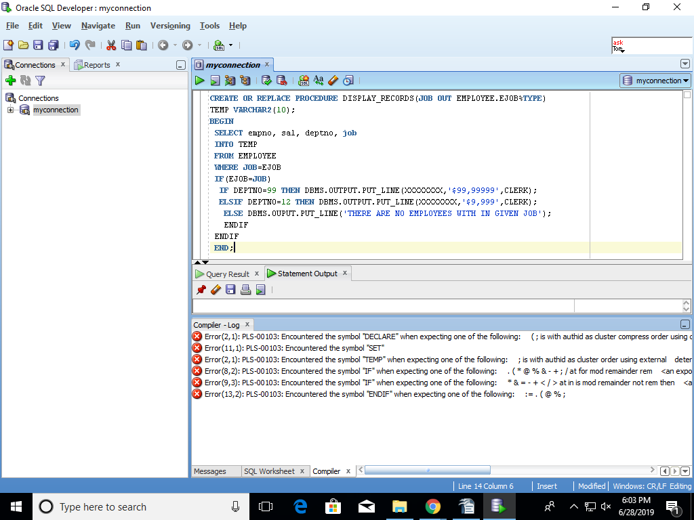

// I have tried these pl sql quaries but I got errors.

- Create a function named GET_EMP_ANNSAL which accepts employee Number as
a parameter and Returns Annual Salary of the given employee from EMP table if the record exist otherwise returns -1 ( formula to computer ANNUAL_SALARY = SAL * 12)

